A Unified Value Function for Heat Dispatch Sensing and Risk-Aware Control in Cascaded PCM Solar Dryers
Abstract
In a solar dryer equipped with multiple phase-change material (PCM) storage, the controllers don't explicitly determine when the heat to be used, conserved or carried over to the next batch should be used. This paper introduces the novel Co-Dynamic Thermal Value Dispatch (CTVD) control framework, which is based on a single graded heat value function. Divisible dispatch results in an ordered value of these gradients being the grade prices, giving a merit-order dispatch rule and closed form shut-off times. Two supporting components, derived from the same function – Decision-Critical Sensing (DCS) – measures only the PCM states that could cause a dispatch decision to be missed, and Mission-Risk Calibration (MRC) – uses Learn-then-Test to bound the probability of violating the drying target for an entire batch. Closed-loop simulations of a published and experimentally validated three-stage solar dryer are used as a test bed for evaluating CTVD, and a grid-discretised dynamic-programming (DP) oracle is used as a performance benchmark. CTVD achieved the drying target in 98.3% of episodes, compared to 92.9% of episodes for the strongest re-implemented published method (multi-timescale chance-constrained dispatch). It also used 13.5% less auxiliary energy (about 123 kg CO₂ avoided per tonne of water removed), needed three sensors instead of six and had the held-out miss rate of 5% or less, while being superior to a full-horizon economic MPC and a deep reinforcement-learning (SAC) controller trained on the same data, with an average decision time of 18.5 ms per decision. Strong model predictive control (MPC) performed with the same miss rate, but required 17.7–25.3% higher auxiliary energy. In the cases of tomato juice, tomato pulp and moringa leaves, the target was met in almost all episodes (98.3-99.2%). All results are simulated and validation on a physical dryer is left for further work.
Keywords: solar drying; cascaded phase change storage; thermal energy value; merit-order dispatch; decision-critical sensing; risk calibration
1. Introduction
Solar drying will not significantly impact energy cost and carbon intensity of agricultural processing, except that solar radiation is not continuous so maintaining the required air condition for a product for 24 hours is difficult [1],[2]. Cascaded phase-change thermal storage (PCTS) is a solution to this, that uses PCMs with different melting points in series, that extends the time period during which useful heat can be obtained and that enhances the thermal match between the collector and the store [5],[6],[7]. To the best of our knowledge, the most detailed study of a cascaded-PCM dryer (Section 2.4) also reveals the limitation that motivates this work, the fact that heat was discharged when moisture removal was no longer possible, as evidenced by the moisture ratio (MR) ceasing to fall. So the issue is not the amount of heat stored, it's how it's utilized. The useful range of heat varies with grade: 80 °C heat can be used to perform the work of 60 °C heat, but not the other way around: this is the principle behind outlet-grade regulation in cascaded packed-bed stores [8]. Also, its value varies within a batch – the drying rate is fast at the onset of the batch and slows down during the end of the batch [9] and kinetic and data-driven energy models [10],[11],[12] indicate that the value of heat increases initially but decreases as the product approaches the desired state. If not picked over at the end of a batch, heat stored in the store is only useful if it can be transferred to the next batch. Note that the store is not reset when a dried batch is unloaded and a wet batch is loaded (a reload) - the time taken to reload will therefore also influence the amount of stored heat that the next batch will receive, thus reloading is a choice of both product and store. All of the existing set-point controllers such as model predictive control (MPC) and reinforcement-learning controllers for thermal storage [13],[14],[15] optimize an energy objective over a forecast horizon, but give neither a value nor a weight to a unit of heat of a given grade at any given stage of drying.
Such a value is used in dispatch, but raises two additional questions. First, on the phase plateau the temperature is constant, but the enthalpy is significantly different, making the detection of the liquid fraction at each step not very reliable [16],[17],[18]; but, if the estimation error causes a change in the dispatch, the error does not matter. Second, unlike comfort-constrained heat-pump scheduling [19],[20] that bounded the probability of violating a constraint at every step, for drying the failure that matters is the moisture miss at the end of the batch - which is an outcome of the entire closed-loop episode. This paper presents a new method called Co-Dynamic Thermal Value Dispatch (CTVD). The method is co-dynamic since three quantities change as a function of the state of the store: the value of the stored heat, the information required to act on the stored heat, and the risk involved in acting on the stored heat. The heat value function is graded; the dispatch, the reload, the sensing and the risk rules are not assembled separately but extracted from the heat value function. The results are valid for any plant model that provides stage heat balances and a drying law, fed as a replaceable substrate. To the best of our knowledge, no previous formulation value has been found that stores heat by temperature grade for a drying process or ranks the effect of PCM sensing on the dispatch ranking of a controller that drains its own thermal store, or provides bounds for the episode-level risk of such a controller. The contributions are as follows:
- Graded heat value and its price dynamics (GHV): Value function on substitution-coordinates (Graded heat value and its price dynamics GHV): Solving of a quasi-variational inequality with an impulse (batch reload). It is a graded Hotelling rule, with its grade prices $p_{3}≥p_{2}≥p_{1}$ increasing as the stage loss rate increases. In combination with a closed-form sink-decay law from Page kinetics, they provide a closed-form solution for the shut-off time for each grade (highest grade first), accounting for the post-batch discharge that was observed in the reference dryer (Section 2.4).
- Decision loss for PCM sensing with two channels (DCS): With two channels of PCM sensing (DCS): The estimation error impacts two channels – curvature of rank at most 2, and the price-gap channel governed by the ratio of the spread between the price of the grade and the uncertainty in the price. Both provide closed-form computing rules for the value of information of a flow-step probe on the phase plateau and for choosing sensors prior to installation.
- Order-preserving mission-risk calibration (MRC): Order preserving mission-risk calibration (MRC): Miss probability is an independent optimization problem from value function, and it can move the entire price ladder without altering the merit order, calibrated over the entire episodes using Learn-then-Test. MRC is a risk–energy trade-off; it costs a guaranteed miss rate for an acceptable energy loss. An exact regret identity is implemented to properly partition the three sources of loss, with Algorithm 1 being an 18.5 ms decision step.
The value of the grade prices is assumed to be explicitly ordered: the prices on the grade should not be reversed if the valves can be partially opened (divisible dispatch). All results are published closed-loop simulations on a model of the dryer, with a model for the drying response and a second model for the cabinet temperature, which are validated with measured closed-loop responses (Section 2.4); the model for the PCM-store and the model for the second product are only checked for consistency with synthetic runs based on three sets of data, public computational fluid dynamics (CFD) and experimental runs (Sections 5.2 and 6.1). The related work is reviewed in Section 2, the plant and sink-decay law in Section 3, the development of the method in Section 4, the description of the experimental setup in Section 5, the results in Section 6, and conclusion in Section 7. Appendix A gives the proofs and Appendix B the conditions of the regret identity.
2. Related work
The work relevant to this topic can be categorized into three areas: design and thermal performance of PCM-assisted solar dryers, data-driven prediction of drying behavior, and control, estimation and risk management of thermal storage. Each strand is reviewed with the question it leaves open; Section 2.4 then reviews the cascaded-PCM dryer used as the plant of this work, and Section 2.5 presents the resulting research gaps.
2.1 PCM-assisted solar drying and cascaded thermal storage
The latent storage prolongs the duration of the drying. Vigneshkumar et al. [21] used indirect forced convection dryer for potato with paraffin PCM and achieved increased moisture removal and useful heat beyond solar period. Das et al. [22] proposed a mixed mode dryer with PCM storage for Baccaurea ramiflora and evaluated the dryer using a 4E (energy, exergy, economic, and environmental) analysis. Abuelnuor et al. [23] reviewed and found that the use of PCM reduces drying time of crops. Atsbeha et al. [24] placed the storage in the collector, simulating a flat-plate air collector with PCM and aluminium fins for providing a longer heat delivery after sunset. This strand is the most advanced, and the three-stage cascaded-PCM dryer used as the plant in this work is discussed separately in Section 2.4. Throughout this strand, however, the store is assessed by how much heat it holds and how fast it releases it. None of these studies asks how much heat should be drawn from each grade at each drying stage, when discharge from a grade should stop, or when heat should be held for the next batch.
2.2 Data-driven and AI-assisted prediction of drying performance
The second strand is the use of learned predictors instead of, or in addition to, physical models. Choubey et al. [25] reviewed the use of machine learning in solar drying using PCM and Chen et al. [26] reviewed the integration of phase change energy storage and machine learning in solar drying. Rajamurugu et al. [27] compared performance of multilayer perceptron (MLP), random forest and support vector regression for the drying of black dates using solar-chimney PCM. The most accurate test-set coefficient of determination (R² = 0.90) was achieved by the multilayer perceptron, where the most significant variables were irradiance and airflow. This strand is judged by prediction accuracy, yet accuracy alone does not determine which grade to discharge, how much high-grade heat to retain or when to reload the store. Where optimisation is used, it tunes design or operating parameters; the marginal value of stored heat is not considered.
2.3 Control, state estimation and risk management of thermal storage
Storage-control studies address how a store is operated and monitored. Wan et al. [28] regulated the power of latent heat storage units with model predictive control (MPC) and an extended Kalman filter (EKF) observer, and Zhao et al. [29] estimated the temperature field and state of charge of a latent store with a physics-informed neural network (PINN). Both treat the store as a single resource judged by tracking or estimation error: neither values heat by grade, separates errors that reverse a dispatch decision from benign ones, or says which PCM state should be measured. On the risk side, Dominguez et al. [30] and Zhang et al. [31] used chance constraints to bound per-step constraint violations in energy communities with thermal and hybrid storage. In a dryer, however, the failure that matters is missing the target moisture by the batch deadline, an outcome of the whole closed-loop episode.
2.4 Reference cascaded-PCM dryer
Li et al. [32] built an experimentally validated dynamic model of a forced-convection dryer using three cascaded PCMs (80, 70 and 60 °C). It increased storage capacity by 8.64% when compared to single-stage storage. Optimized set-point and rule-based control resulted in an 8.61% increase in moisture evaporation and a 13.05% increase in system efficiency, and a 35.7% reduction in inlet-air temperature fluctuations. After the moisture removal was complete, however, 2119.8 kJ of heat was discharged. This system is used as the reference dryer in this work and is used to provide the plant model, Page kinetics, the effective-conductivity correlation, and the weather data and rule-based baseline. The post-batch heat discharge is a measure of the inefficiency of its operation, which the proposed method seeks to resolve.
2.5 Research gaps
Closest prior ideas: There are three concepts that are closest to graded heat value. Water-value and exhaustible-resource (Hotelling) pricing involve a marginal value of a stored stock, but a single homogeneous stock that is serving an exogenous demand. Grade regulation of cascaded packed beds [8] is a method that regulates the outlet temperature of each stage to the temperature a load needs, but does not put a cost on a grade or determine when to discontinue its use. The stored energy is only indirectly accounted for in storage controllers that are based on MPC or reinforcement learning [13-15,28] via a terminal cost on total energy. GHV differs from all three: heat is priced by substitution between grades, the grade prices are linked to drying progress through the decaying sink of Eq. 3, and the prices persist through a reload, which is treated as an impulse decision on the store. Gap 1: Dryer investigations [21-24,32] optimize storage capacity, heat transfer and temperature stability, learned models [25-27] predict performance, and storage controllers [28] monitor a power reference. No study has assigned a value to stored heat that combines grade, drying progress and reload, so the dispatch order, shut-off times and reload decision implied by such a value have not been derived. Gap 2: With latent-storage observers [28,29] the estimation error is minimized uniformly, but they do not identify which errors will change or reverse a dispatch decision. Gap 3: The risk-aware storage dispatch [30,31] limits the probability of violating the storage requirements per step. None of them estimates how likely it is that a closed loop that depletes its own store will miss the drying target over an episode. GHV, DCS and MRC address Gaps 1–3, respectively, and each is tested against the strongest method for its gap with the other two components switched off.
3. System formulation and substrate

3.1 Plant and substrate dynamics
The plant is the three-stage cascaded-PCM reference dryer of Li et al. [32] (Section 2.4): three PCM units in series (an erythritol-based mixture, stearic acid and paraffin wax, melting at 80, 70 and 60 °C), a flat-plate collector that charges the store, a vacuum-tube collector that heats the drying air directly, and a heat exchanger that delivers stored heat to the cabinet. Stages are numbered sequentially by grade, k=1,2,3 for 60, 70 and 80 °C, respectively. Time is in hours, heat in kJ and power in kJ h⁻¹. The substrate is any model which provides stage heat balances and a drying law; the enthalpy of the stage k changes with time as
${\dot{H}}_{k}=Q_{k}^{c}\left(t\right)-P_{k}\left(t\right)-l_{k}\left(H_{k},t\right), 0≤P_{k}≤{\overset{‾}{P}}_{k}\left(H_{k}\right), l_{k}=U_{k}A_{k}\left(T_{k}^{pcm}-T_{amb}\right)+softplus\left(g_{ϑ}\right)$ (1)
where $Q_{k}^{c}$ is the collector charging, $P_{k}$ the discharge power, ${\overset{‾}{P}}_{k}\left(H_{k}\right)$ its upper bound and $l_{k}$ the heat loss, with stage loss coefficient $U_{k}$, area $A_{k}$, PCM temperature $T_{k}^{pcm}$, ambient temperature $T_{amb}$ and a learned correction $g_{ϑ}$ that can only add loss. The correction $g_{ϑ}$ represents losses that the lumped term misses, such as those through valves, piping and a convecting melt. It is a small fully connected network with parameters ϑ, whose inputs are $(T_{k}^{pcm}-T_{amb},γ_{k},ṁ)$, where γ_{k} is the liquid fraction of stage k; it is fitted once in the offline calibration step (Algorithm 1, step 1) by least squares on the stage heat-balance residual $Ḣ_{k}-Q_{k}^{c}+P_{k}-U_{k}A_{k}(T_{k}^{pcm}-T_{amb})$ over the training split of the PCM datasets (Section 5.2), with $U_{k}A_{k}$ fixed at the values of Table 1. It is then frozen, and the same calibrated substrate is used by the simulator, by the training of the value and miss-probability networks (Section 4) and by every baseline, so it does not favour any controller. The air leaving the exchanger has temperature T=Tin+k​ηkPk+Paux/mcp, with collector outlet temperature $T_{in}$, exchanger effectiveness $η_{k}$, auxiliary power $P_{aux}$, air flow $\dot{m}$ and specific heat $c_{p}$; in this expression $\dot{m}$ is converted from the kg s⁻¹ of Table 1 to kg h⁻¹, so that every term is in kJ h⁻¹. Drying progress is the dryness $u=-lnMR$. With the Page law $MR=exp\left(-\left|k\left(T\right)\right| t^{n\left(T\right)}\right)$ and the equivalent-time construction of the reference dryer,
$\dot{u}=b\left(T\right) u^{ζ\left(T\right)}, b\left(T\right)=n\left(T\right) {\left|k\left(T\right)\right|}^{1/n\left(T\right)}, ζ\left(T\right)=1-\frac{1}{n\left(T\right)}$ (2)
with Page coefficients $k\left(T\right)=0.0001T^{2}+0.0084T-0.3369$ and $n\left(T\right)=0.7568+0.018T-0.0001T^{2}$ (as fitted for the reference dryer; written with the sign for which k > 0 above 29.6 °C, so that the absolute value in Eq. 2 is redundant over 40–80 °C and the values of ξ, MR† and Λ below are reproduced; the original equation also misprints the linear term of $n$ as $0.18T$). Between 40 and 80 °C, $n$ = 1.32–1.56, so $0<ζ<1$. The state is $x=\left(H_{1},H_{2},H_{3},u\right)$. Flow: Eq. 1 maps the decisions $P_{k}$ to enthalpies and air temperature; Eq. 2 maps air temperature to drying rate; both feed Eqs. 3, 5 and 7.

3.2 Sink-decay law
Since $MR=e^{-u}$, heat is worth the moisture it removes, $-dMR/dt=e^{-u}\dot{u}$. With $ρ_{w}$ the value of a unit decrease in moisture ratio (value units, v.u.), the marginal water-removal value of one more degree of air temperature, $β=ρ_{w}e^{-u}∂\dot{u}/∂T$, follows from Eq. 2 as
$β\left(u,T\right)=ρ_{w} b\left(T\right) ζ'\left(T\right) e^{-u} u^{ζ\left(T\right)}\left[ξ\left(T\right)+lnu\right], ξ\left(T\right)=\frac{b'\left(T\right)}{b\left(T\right) ζ'\left(T\right)}, ζ'\left(T\right)=\frac{n'\left(T\right)}{n{\left(T\right)}^{2}}$ (3)
where primes denote $d/dT$; $e^{-u}$ is the decaying sink and $u^{ζ}$ the start-up of the falling-rate period.
Proposition 1 (sink-decay law). For fixed $T$ with $b'>0$ and $ζ'>0$, $β\left(⋅,T\right)$ has a unique maximum on $u>e^{-ξ}$ at the root $u^{†}$ below, and for a batch ending at target dryness $u_{f}=-lnMR_{f}>u^{†}$ the peak-to-end decay ratio is
$u^{†}=ζ+\frac{1}{ξ+lnu^{†}}, Λ\left(u_{f}\right)≡\frac{β\left(u^{†},T\right)}{β\left(u_{f},T\right)}=e^{ u_{f}-u^{†}}{\left(\frac{u^{†}}{u_{f}}\right)}^{ζ}\frac{ξ+lnu^{†}}{ξ+lnu_{f}}$ (4)
The proof is given in Appendix A. In simple terms, a unit of heat removes the most water when about one third of the removable moisture has gone, and much less towards the end of the batch. Stored heat should therefore not be spent at the end of a batch at the rate used in the middle.
With the reference-dryer coefficients, $ξ$ = 11.7–21.1 over 45–80 °C. The value of drying heat peaks at $MR^{†}$ = 0.66–0.71 and then decays (Fig. 1a); Λ is 3.2–3.7 for $MR_{f}=0.1$ and 13.0–15.5 for $MR_{f}=0.02$, growing roughly as $1/MR_{f}$ (Fig. 1b). The decay is therefore set by the target, not by the process. Flow: Eq. 3 is the benefit used in dispatch (Eq. 11) and shut-off (Eq. 13); $u^{†}$ opens the shut-off window of Eq. 13.
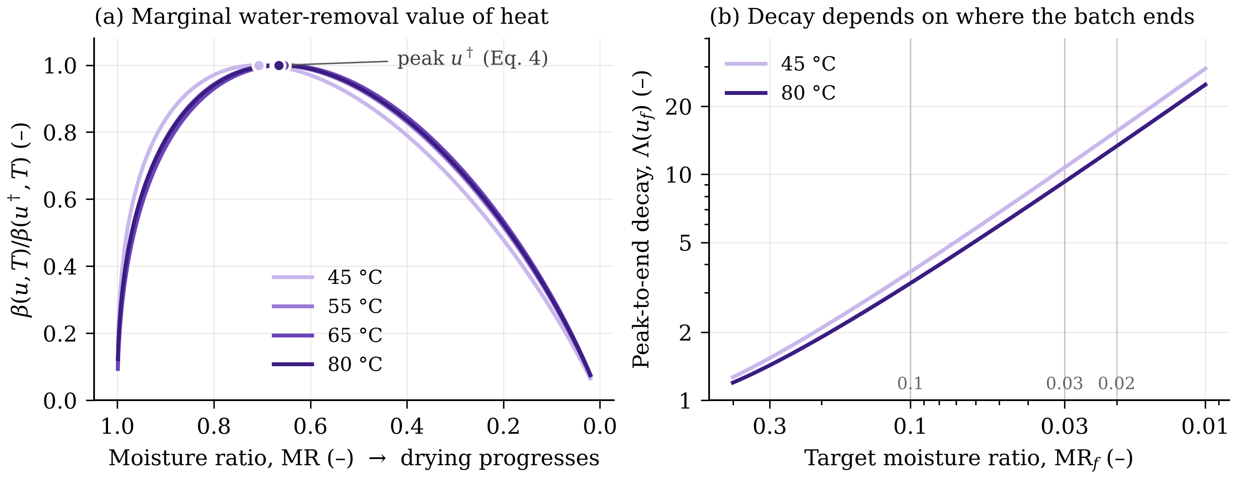
Fig. 1. Sink-decay law from the Page kinetics of the reference dryer. (a) Marginal water-removal value of heat (Eq. 3), normalized to its peak; markers show the closed-form peak $u^{†}$ of Eq. 4. (b) Peak-to-end decay ratio $Λ\left(u_{f}\right)$ of Eq. 4 against the target moisture ratio. The figure establishes that the value of drying heat is set by the target moisture ratio, which is the basis of the shut-off rule of Proposition 5.
4. The CTVD methodology

4.1 Organizing principle
Fig. 2 shows where CTVD sits on the plant of Section 3.1. It reads the air, humidity, product-moisture and PCM measurements, estimates the drying and PCM states, and at every step sets the PCM valve openings, auxiliary heater power, airflow, grade-wise shut-off times and the reload decision.
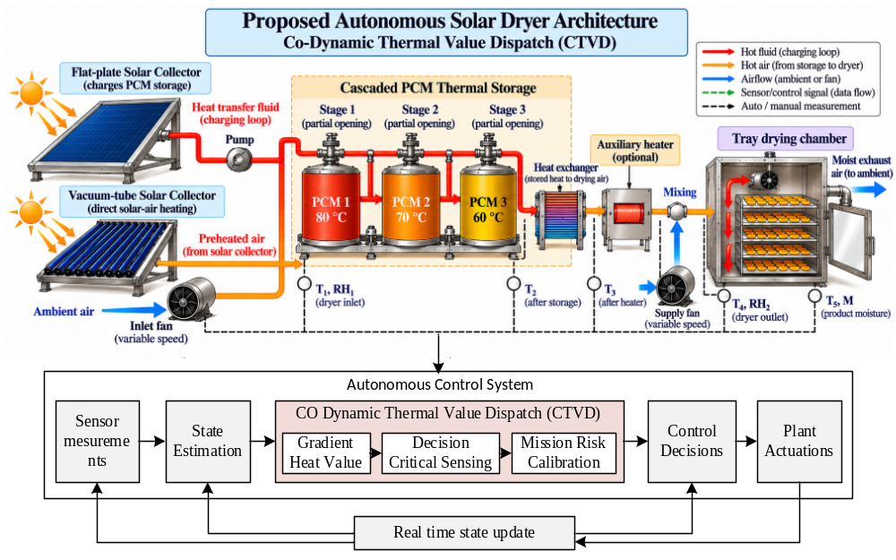
Fig. 2. Plant and closed control loop of the CTVD-controlled cascaded-PCM solar dryer. (a) Plant: a flat-plate collector charges three PCM stages through a proportional-valve heat-transfer loop, and a vacuum-tube collector heats the drying air directly; stored heat reaches the air through the heat exchanger and is topped up by the auxiliary heater before the tray chamber. Circles mark candidate measurement points, of which DCS selects the subset used online. Stages are labelled by grade, k = 3, 2 and 1 for 80, 70 and 60 °C. (b) Control loop: measurements feed state estimation, and CTVD (GHV, DCS and MRC) sets the valve openings, auxiliary heater power, airflow and grade-wise shut-off times and decides whether to reload or carry heat to the next batch, re-dispatching at every step.
Every quantity in CTVD is a functional of one object, the graded heat value function $V\left(q,u,t\right)$ (Fig. 3):
$$x\overset{\text{Eq. 5}}{→}q\overset{\text{Eqs. 7–8}}{→}V\overset{\text{Eq. 9}}{→}p_{k}\overset{\text{Eqs. 10–11}}{→}π^{⋆}\overset{\text{Eqs. 12–14}}{→}\left(t_{k}^{off},S\right)\overset{\text{Eqs. 17–18}}{→}\left(Γ_{D},Δp_{k},σ_{k}\right)\overset{\text{Eqs. 19–20}}{→}\hat{x}\overset{\text{Eqs. 21–22}}{→}R\left(ρ\right)\overset{\text{Eq. 23}}{→}\hat{ρ}\overset{\text{Eq. 24}}{→}\text{regret}$$
The price is a gradient of V, dispatch maximizes its Hamiltonian, and the decision-loss matrix and price gaps are its second derivatives. The miss probability that determines the risk premium is used to solve the same operator but with a different reward. If V is removed, DCS and MRC are both undefined, but they can be tested separately: GHV with a perfect state and known weather conditions, DCS with any dispatch rule based on price, and MRC with any controller that provides a price premium.
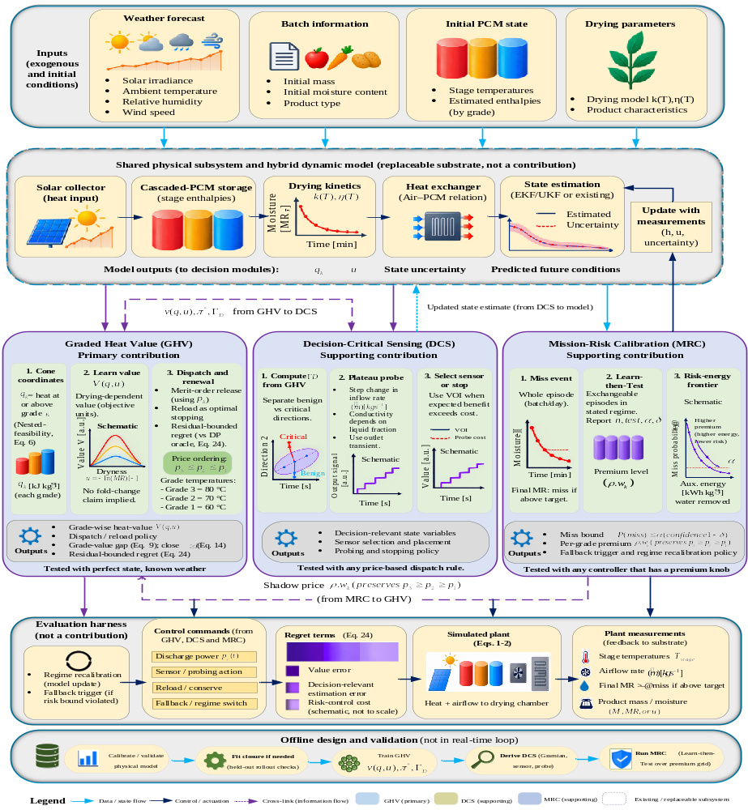
Fig. 3. Overall architecture of CTVD. Inputs (weather forecast, batch information, initial PCM state and drying parameters) drive a shared physical model with state estimation, which is a replaceable substrate rather than a contribution. Graded Heat Value (primary contribution) maps the state to cone coordinates, learns the forecast-conditioned value function V(q,u,t;fₜ) and derives merit-order dispatch, ordered grade prices, grade-wise shut-off and reload. Decision-Critical Sensing uses the decision-loss geometry supplied by GHV to separate benign from critical estimation errors, decide plateau probes and select sensors. Mission-Risk Calibration validates an order-preserving premium ρ w_{k} by Learn-then-Test and returns it to GHV as a shift of the grade prices. The evaluation harness applies the resulting commands to the simulated plant (no hardware is in the loop) and splits regret into value, estimation and risk-control terms (Eq. 24); the bottom row lists the offline design steps.

4.2 Graded Heat Value (primary contribution)
Substitution-cone coordinates. Let $h_{j}=max\left(H_{j}-H_{j}^{min},0\right)$ be the heat deliverable from grade $j$, where $H_{j}^{min}$ is the enthalpy below which stage $j$ cannot supply air at its grade temperature. Value is defined on the heat available at or above each grade,
qk=j≥k​hj, q1≥q2≥q3≥0 (5)
so one unit of grade-$k$ heat raises $q_{1},…,q_{k}$ only (Fig. 4a). Let $D_{k}\left(q\right)$ be the air-temperature and power profiles that grade-$k$ heat alone can deliver over the rest of the campaign, which ends at $T_{h}$. The only structural assumption is nested feasibility (Fig. 4b),
$D_{k}\left(q\right)⊆D_{k+1}\left(q\right) \text{for all feasible }q, k=1,2$ (6)
which holds for the reference dryer because its diverter and shunt valves let a higher stage be throttled to any outlet temperature a lower stage can deliver.
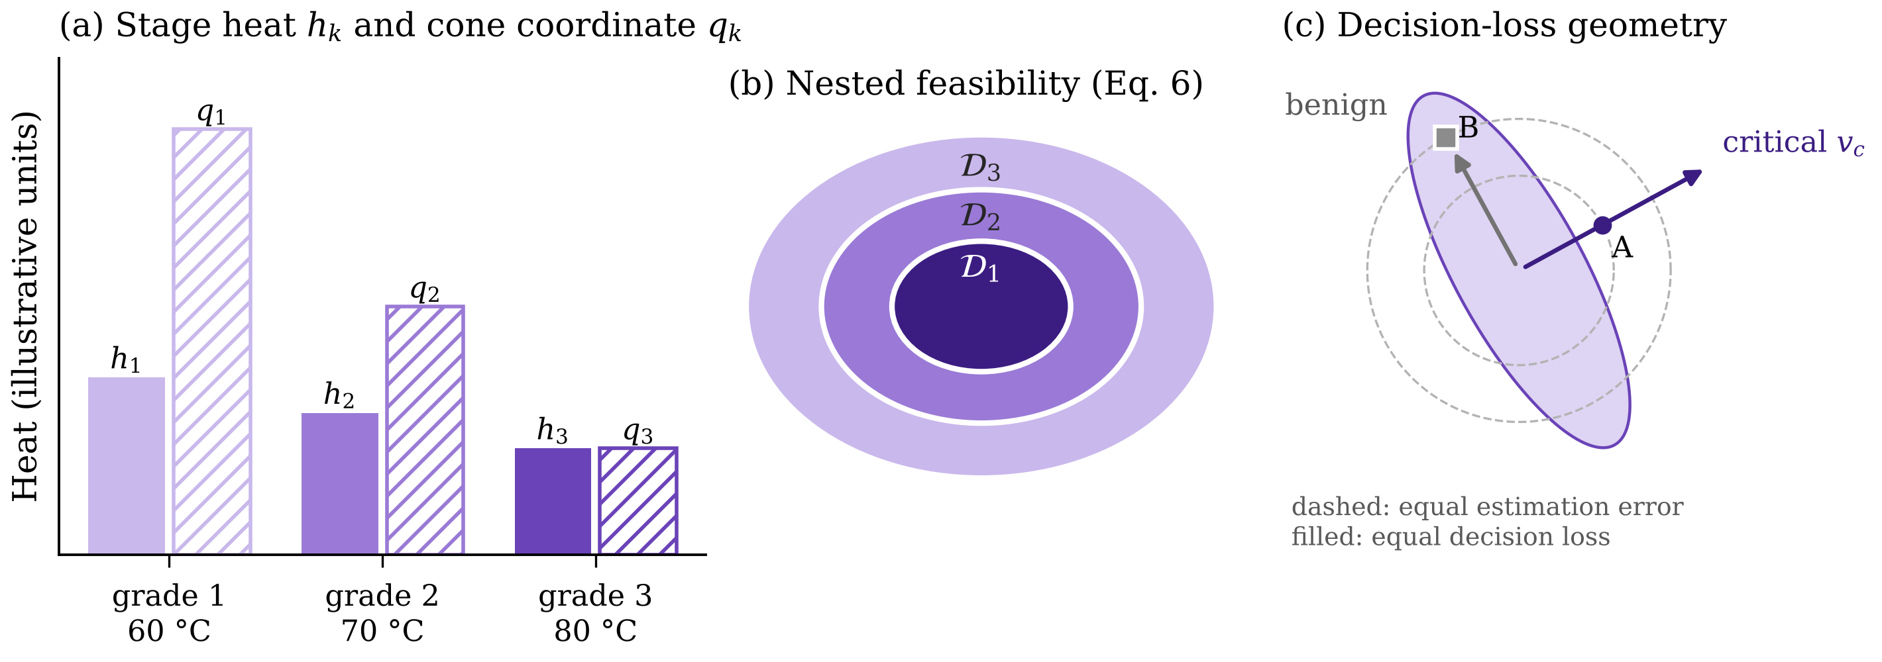
Fig. 4. Geometry of graded heat and decision-relevant error (illustrative). (a) Stage heat $h_{k}$ and cone coordinate $q_{k}$ (Eq. 5). (b) Nested feasible sets (Eq. 6). (c) Curvature channel (Eqs. 17–18): estimator A has the smaller error but, lying along the decision-critical direction $v_{c}$, incurs the larger dispatch loss. The figure illustrates why price ordering rests on nested feasibility and why a smaller estimation error does not guarantee a smaller dispatch loss.
Objective and renewal value function. The controller maximises the value of moisture removed less the cost of auxiliary heat over a campaign with reloads at times $τ_{i}$:
Jπ=E0Thρw e-u uTπ,u-caPaux dt+i​ruτi- (7)
where $π$ maps the state to actions $a=\left(P_{1},P_{2},P_{3},P_{aux},\dot{m}\right)$, $c_{a}$ is the price of auxiliary heat and $r\left(u\right)=ρ_{b}1\{u≥u^{⋆}\}-c_{r}$ is the batch reward, with batch value $ρ_{b}$, target dryness $u^{⋆}$ and reload cost $c_{r}$. Reload resets $u$ to zero but keeps the stored heat $q$, so the value function $V\left(q,u,t\right)=\sup_{π}J\left(π∣q,u,t\right)$ solves the quasi-variational inequality
$max\left\{∂_{t}V+\sup_{a∈P\left(q,u,t\right)}\left[ρ_{w}e^{-u}\dot{u}-c_{a}P_{aux}+∇_{q}V⋅\dot{q}+∂_{u}V \dot{u}\right], MV-V\right\}=0, MV\left(q,u,t\right)=r\left(u\right)+V\left(q,0,t\right)$ (8)
with $V\left(q,u,T_{h}\right)=r\left(u\right)$, admissible action set $P$ and reload operator $M$. The bracket is the Hamiltonian $H\left(x,∇V\right)$; its term $∂_{u}V \dot{u}$ prices drying progress and couples the current batch to the next. Relative to water-value theory, the sink decays through $u$, the store is graded through $q$ and the system regenerates through $M$.
Weather and forecast. Weather enters CTVD as an exogenous input, not as a controlled state: irradiance and ambient temperature drive the collector charging $Q_{k}^{c}$, the collector outlet temperature $T_{in}$ and the loss term of Eq. 1. Let $f_{t}$ denote the weather information available at time $t$, namely the 4 h irradiance and ambient-temperature forecast of Section 5.1. The expectation in Eq. 7 is taken over the weather trajectories of the regime conditional on $f_{t}$, and the value function is conditioned on it, $V(q,u,t;f_{t})$; the argument $f_{t}$ is suppressed below where it is not needed. When the residual of Eq. 8 is evaluated, $Q_{k}^{c}$, $T_{in}$ and $T_{amb}$ are taken from the forecast. In the network of Eq. 16 the forecast enters only the unconstrained bias, $d_{l}(u,t,f_{t})$, so the monotonicity of $V_{θ}$ in $q$, and with it the price ordering of Proposition 2, holds for every forecast. Online, the forecast is refreshed at every decision interval (Algorithm 1, step 5) and the prices are recomputed, so a forecast revision moves the whole price ladder without reordering it. In the GHV-only test of Section 6.3, $f_{t}$ is the realised weather (known weather); in the integrated test of Section 6.6, it is the persistence forecast with first-order autoregressive (AR(1)) error. The miss-probability function $W$ of Section 4.4 is conditioned on $f_{t}$ in the same way.
Grade prices and their ordering. The price of grade-$k$ heat is the marginal value of one more unit at that grade:
pk=∂V∂hk=j≤k​∂V∂qj (9)
with adjacent spread $Δp_{k}=p_{k}-p_{k-1}=∂V/∂q_{k}$.
Proposition 2 (price ordering). Under divisible dispatch, and when the marginal standing loss of deliverable heat does not increase with grade, $∂l_{j}/∂h_{j} ≤ ∂l_{j-1}/∂h_{j-1}$, Eq. 6 implies that $V$ is non-decreasing in each $q_{j}$, hence
$p_{3}≥p_{2}≥p_{1}≥0$ (10)
The proof is given in Appendix A. The loss condition is mild: on the phase plateau $∂l_{k}/∂h_{k}$ is small for every grade, because melting ranges of 3–4 K are spread over at least 2850 kJ of latent heat per stage (Table 1). The oracle check of Section 6.2 found no state that violated Eq. 10 under divisible dispatch. With on–off valves the inclusion of Eq. 6 fails and Eq. 10 need not hold, so divisibility is a condition of the result. For an operator, this means that with proportional valves a unit of 80 °C heat is never worth less than a unit of 60 °C heat; with on–off valves this ranking is not guaranteed.
Proposition 3 (merit-order dispatch). With Eq. 9 in Eq. 8, dispatch solves supaρwe-u+∂uVu-caPaux-k​pkPk within the power bounds, whose Karush–Kuhn–Tucker conditions are
$β_{k}=ψ β\left(u,T\right) \frac{η_{k}}{\dot{m}c_{p}}, ψ=1+\frac{e^{u} ∂_{u}V}{ρ_{w}}, β_{k}-p_{k}=μ_{k}-ν_{k}, μ_{k}\left({\overset{‾}{P}}_{k}-P_{k}^{⋆}\right)=0, ν_{k}P_{k}^{⋆}=0$ (11)
where $β_{k}$ is the marginal benefit of stage-$k$ power, $ψ$ the continuation factor and $μ_{k},ν_{k}≥0$ the bound multipliers. A grade is used only while $β_{k}≥p_{k}$; the auxiliary heater is a fourth grade with fixed price $c_{a}$. Since $β_{k}$ differs across stages only through $η_{k}$ while prices are ordered, the optimal policy draws on the lowest admissible grade first; the grade with $0<P_{k}^{⋆}<{\overset{‾}{P}}_{k}$ is the marginal grade $k_{m}$. This lowest-grade-first rule requires the effectiveness differences to be small relative to the price spread, $(η_{k} - η_{k-1}) ψ β/(ṁ c_{p}) ≤ Δp_{k}$, which the near-equal effectiveness of Table 1 makes easy to meet. For an operator: draw on the 60 °C stage first, open the 70 °C and 80 °C stages only when the lower grade cannot hold the air temperature or is exhausted, and call the auxiliary heater only while its price $c_{a}$ is below the marginal benefit.
Proposition 4 (graded Hotelling rule). Between reloads, for a known weather path and collector charging $Q_{k}^{c}$ that does not depend on $h_{k}$, the prices along the optimal path satisfy
${\dot{p}}_{k}=p_{k} \frac{∂l_{k}}{∂h_{k}}-μ_{k} \frac{∂{\overset{‾}{P}}_{k}}{∂h_{k}}$ (12)
The proof is in Appendix A. Just as the price of an exhaustible resource must rise at the interest rate, the value of stored heat must rise at its leak rate to justify keeping it; prices are continuous across a reload. Under a forecast that is revised over time, Eq. 12 gives the expected drift of $p_{k}$ conditional on $f_{t}$ between revisions, and each revision adds a zero-mean change in the price. For an operator, heat is worth keeping for later only if its value rises at least as fast as it leaks.
Proposition 5 (value-optimal shut-off). In a window $W=[t_{w},τ)$ before reload with $u≥max\left(u^{†},u^{⋆}\right)$, constant air temperature $\overset{‾}{T}$ and air flow $ṁ$, slack bounds, $∂l_{k}/∂h_{k}≥0$ and non-increasing $ψ$, each grade switches off at most once, at
$t_{k}^{off}=inf\left\{t∈W:ψ\left(t\right) β\left(u\left(t\right),\overset{‾}{T}\right) \frac{η_{k}}{\dot{m}c_{p}}<p_{k}\left(t\right)\right\}, t_{3}^{off}≤t_{2}^{off}≤t_{1}^{off} \text{if }\frac{η_{3}}{p_{3}}≤\frac{η_{2}}{p_{2}}≤\frac{η_{1}}{p_{1}}$ (13)
where the order condition on $η_{k}/p_{k}(t)$ must hold throughout $W$, because prices drift at their own loss rates (Eq. 12). The proof is given in Appendix A. With near-equal $η_{k}$ the highest grade shuts off first. Heat released after $t_{1}^{off}$ removes less water than it is worth in the next batch; this is the decision-theoretic account of the 2119.8 kJ discharged by the reference dryer. For an operator: near the end of each batch, close the 80 °C stage first, then the 70 °C and 60 °C stages, instead of discharging every stage until the batch ends.
Proposition 6 (reload as optimal stopping). The reload region is
$S=\left\{\left(q,u,t\right):MV\left(q,u,t\right)=V\left(q,u,t\right)\right\}$ (14)
so heat still held at $t_{1}^{off}$ favours an earlier reload, where it meets a fresh batch near $u^{†}$. The advantage of grading is measured by the gap to the best grade-blind policy $V_{agg}$, which dispatches on a single scalar heat state (Table 3) instead of the cone coordinates:
Δgradex=Vx-Vaggx≥0, Δgradex=EtThk≥2​pk-p1 mks ds+o∥m∥ (15)
where $m_{k}\left(s\right)$ is the rate at which the grade-blind policy spends grade-$k$ heat on grade-1 work. Eq. 15 predicts, before any controller is run, that grading pays most when high-grade heat is misspent while spreads are large, so a designer can use it to judge whether grading is worth implementing on a given plant.
Structure-preserving learned value function. For the full plant, $V$ is approximated by a network that is non-decreasing in $q$ and trained on the residual of Eq. 8:
$z_{l+1}=ϕ\left(softplus\left(W_{l}\right) z_{l}+softplus\left(Ω_{l}\right) q+d_{l}\left(u,t\right)\right),V_{θ}=κ^{⊤}z_{\overset{‾}{l}},ϵ_{θ}=\sup_{x∈X}\left|max\left\{∂_{t}V_{θ}+H\left(x,∇V_{θ}\right), MV_{θ}-V_{θ}\right\}\right|$ (16)
where $W_{l},Ω_{l}$ are made non-negative by the softplus, $d_{l}\left(u,t\right)$ is an unconstrained bias network, $ϕ$ is a smooth, convex and strictly increasing activation, $κ≥0$, and $ϵ_{θ}$ is the residual over the training region $X$. Every price is then non-negative and ordered for any parameter values. Flow: Eqs. 5–8 give $V$; Eqs. 9–11 give prices and dispatch; Eqs. 12–14 give price paths, shut-off times and reload; Eq. 16 replaces $V$ by $V_{θ}$ in Eqs. 9–24.

4.3 Decision-Critical Sensing (supporting contribution)
Each stage is described by PCM temperature and liquid fraction $γ_{k}$, so the estimator works on $x={\left(T_{k}^{pcm},γ_{k},u\right)}_{k=1,2,3}$. Let $Q\left(x,a\right)$ be the action value of Eq. 8 and $\hat{x}=x+e$ the estimate. Under merit order an error can shift the level of delivered heat, set by $a_{c}=\left(T,\dot{m}\right)$, or reverse the order of two adjacent prices. The resulting loss is
$L\left(e\right)=\frac{1}{2} e^{⊤}Γ_{D} e+\sum_{k=2}^{3}{Δ}p_{k} {\overset{‾}{E}}_{k} 1\left\{Δp_{k}+∇_{x}Δp_{k}^{⊤}e<0\right\}+O\left(∥e∥^{3}\right),Γ_{D}=Q_{xa_{c}}{\left(-Q_{a_{c}a_{c}}\right)}^{-1}Q_{a_{c}x},Q_{a_{c}x}=∇_{x}\left(β_{k_{m}}-p_{k_{m}}\right)$ (17)
where $Γ_{D}$ is the decision-loss matrix of the curvature channel and $Q_{a_{c}a_{c}}≺0$ the action curvature. $Q_{a_{c}x}$ is the state gradient of the first-order condition with respect to $a_{c}$; its air-temperature row is the gradient of the marginal grade’s benefit minus price (Eq. 11), and its flow row is formed in the same way from $∂Q/∂ṁ$. Finally, ${\overset{‾}{E}}_{k}$ is the heat drawn from the wrong grade in one interval $Δt$. The first term is second order by the envelope theorem; the second is first order, since a reversal wastes $Δp_{k}$ per unit of heat. Because $Γ_{D}$ factors through $a_{c}$, rank $Γ_{D}≤2$, and because $∇_{x}Δp_{k}$ is a row of the Hessian of $V$, the price-gap channel is sensitive exactly where heat of that grade is scarce. With posterior $e∼N\left(0,Σ\right)$, Σ=Σ0-1+t​Ξt⊤Σv-1Ξt-1 for prior covariance Σ₀, measurement Jacobians $Ξ_{t}$ and noise covariance $Σ_{v}$,
EL=12trΓDΣ+k=23Δpk Ek Φ-Δpkσk, σk2=∇xΔpk⊤ Σ ∇xΔpk, trΓDΣ=i​λi, ΓDvi=λiΣ-1vi (18)
where $Φ$ is the standard normal distribution function and $\left(λ_{i},v_{i}\right)$ are generalised eigenpairs. The decision-critical subspace $C$ spans the eigenvectors carrying a fraction $1-ε_{c}$ of the trace and the directions $Σ∇_{x}Δp_{k}$ with $Δp_{k}/σ_{k}≤z_{c}$. An estimator with smaller $trΣ$ can therefore give a larger loss (Fig. 4c), and a sensor set $S$ suffices when $C⊆range\left(Ξ_{S}^{⊤}\right)$, which selects thermocouples before installation. Here, ε_{c} is the tolerance on the retained curvature trace and z_{c} is the critical standard score below which a price gap is treated as at risk of reversal.
Plateau probe. In the effective-conductivity relation of the reference dryer, $k_{pcm}=γk_{e}+\left(1-γ\right)k_{pcm,s}$ with $k_{e}/k_{pcm,s}=C_{Ra}Ra^{0.25}$; here, k_{e} is the effective conductivity of the convecting melt, k_{pcm,s} the solid-phase conductivity, Ra the Rayleigh number of the melt and C_{Ra} the correlation constant of [32], so $∂k_{pcm}/∂γ>0$ whenever the melt convects. A short flow step $Δ\dot{m}$ thus produces an outlet transient whose amplitude depends on $γ$ with sensitivity $s$ and measurement-noise standard deviation $σ_{A}$. The probe maximises information along a critical direction $v_{c}$:
$Δ{\dot{m}}^{⋆}=arg\max_{Δ\dot{m}} \frac{s{\left(γ,Δ\dot{m}\right)}^{2}}{σ_{A}^{2}\left(Δ\dot{m}\right)} {\left(v_{c}^{⊤}e_{γ}\right)}^{2} \text{s.t.} T_{out}∈\left[T_{min},T_{max}\right], \left|Δ\dot{m}\right|≤Δ_{max}$ (19)
In Eq. 19, e_{γ} is the unit vector that selects the liquid-fraction component of the state, T_{out} is the exchanger outlet air temperature, which must stay within the product limits [T_{min}, T_{max}] (40–75 °C, Table 1), and Δ_{max} is the largest admissible flow step (0.020 kg s⁻¹, Table 1). With $ς=s^{2}/σ_{A}^{2}$, $d_{1}=e_{γ}^{⊤}ΣΓ_{D}Σe_{γ}$ and $d_{2}=e_{γ}^{⊤}Σe_{γ}$, the Sherman–Morrison identity gives both channels after the probe in closed form, and the probe is applied only if
$ΔE\left[L\right]=\frac{ς d_{1}}{2\left(1+ς d_{2}\right)}+\sum_{k=2}^{3}{Δ}p_{k} {\overset{‾}{E}}_{k}\left[Φ\left(-\frac{Δp_{k}}{σ_{k}}\right)-Φ\left(-\frac{Δp_{k}}{σ_{k}^{+}}\right)\right]>c_{probe},{\left(σ_{k}^{+}\right)}^{2}=σ_{k}^{2}-\frac{ς {\left(∇_{x}Δp_{k}^{⊤}Σ e_{γ}\right)}^{2}}{1+ς d_{2}}$ (20)
Without a price gap at risk this reduces to $ς>2c_{probe}/\left(d_{1}-2c_{probe}d_{2}\right)$, which can be met only when $d_{1} > 2c_{probe} d_{2}$; otherwise the probe never pays. Probing pays when two grades are nearly equal in price or heat is scarce, and never when the probed direction is decision-benign. Flow: Eqs. 17–18 take $β_{k}$, $k_{m}$ and $p_{k}$ from Eqs. 9–11; Eq. 19 takes $v_{c}$ from Eq. 18; a probe passing Eq. 20 refines $\hat{x}$ for Section 4.4.

4.4 Mission-Risk Calibration (supporting contribution)
The unit of risk control is a whole episode $ω$ with controller and estimator in the loop, so estimation error is part of the controlled risk:
$I\left(ρ;ω\right)=1\left\{u_{T_{d}}\left(π_{ρ},\hat{x},ω\right)<u^{⋆} ∨ \max_{t≤T_{d}}Ψ\left(x_{t}\right)>0\right\}, R\left(ρ\right)=E_{ω} I\left(ρ;ω\right)$ (21)
where $π_{ρ}$ is the policy with premium $ρ$ acting on $\hat{x}$, $T_{d}$ the batch deadline and $Ψ≤0$ the temperature constraints. Let $W\left(q,u,t\right)=\inf_{π}Pr\left(\text{miss}∣q,u,t\right)$. $W$ solves the operator of Eq. 8 with zero running reward and the miss indicator as terminal reward. It is therefore learned with the network class of Eq. 16 applied to $-W$, and by the argument of Proposition 2 it is non-increasing in each $q_{j}$. For an admissible miss rate α, relaxing the constraint $Pr\left(\text{miss}\right)≤α$ with multiplier $ρ≥0$ gives the Lagrangian value $V_{ρ} = sup_{π} E[J - ρ 1\{miss\}]$. CTVD prices with its computable upper bound $V-ρW$ $≥ V_{ρ}$, formed from the two trained networks, so the premium-adjusted prices are
pkρ=pk+ρ wk, wk=-j≤k​∂W∂qj≥0 (22)
Proposition 7 (premium preserves ordering). Since $-∂W/∂q_{j}≥0$, $w_{3}≥w_{2}≥w_{1}≥0$ and $p_{3}^{ρ}≥p_{2}^{ρ}≥p_{1}^{ρ}$ for every $ρ≥0$: one scalar shifts the whole price ladder towards conservation without breaking the merit order (Eq. 11) or the shut-off order (Eq. 13).
Miss probability need not be monotone in $ρ$, since a high premium can starve the high-value early batch (Eq. 4). Learn-then-Test [33] is therefore applied over a grid $G$ with $n_{c}$ calibration episodes, confidence parameter δ and empirical risk $\hat{R}\left(ρ\right)$, the fraction of calibration episodes that miss the target; Bin(n_{c}, α) denotes a binomial random variable with n_{c} trials and success probability α:
${\hat{p}}_{ρ}=Pr\left[Bin\left(n_{c},α\right)≤n_{c}\hat{R}\left(ρ\right)\right], \hat{G}=\left\{ρ∈G:{\hat{p}}_{ρ}≤\frac{δ}{\left|G\right|}\right\}, Pr\left[R\left(ρ\right)≤α ∀ρ∈\hat{G}\right]≥1-δ$ (23)
Proposition 8 (episode-level risk guarantee). If calibration and deployment episodes are independent draws from the same regime distribution, Eq. 23 holds for all validated premiums simultaneously, by validity of the binomial p-values and the Bonferroni correction. Because the test is applied to whole episodes, the guarantee does not depend on how closely $V - ρW$ approximates $V_{ρ}$. The deployed premium $\hat{ρ}$ is the validated one with least auxiliary energy; if $\hat{G}$ is empty, the rule-based strategy of the reference dryer [32] is used. A zero-miss guarantee with $α=0.05$, $δ=0.1$ and $\left|G\right|=10$ requires $n_{c}≥ln\left(\left|G\right|/δ\right)/\left[-ln\left(1-α\right)\right]≈90$ episodes. For an operator, the guarantee means that, under conditions like those calibrated on, the controller misses the drying target in no more than a fraction α of batches with confidence 1 − δ.

4.5 Exact regret decomposition
Let $π_{θ,ρ}$ be the policy induced by $V_{θ}$ with premium $ρ$ and $J\left(π;\hat{x}\right)$ the return when $π$ acts on the estimate. Proposition 9. Under conditions C1–C4 of Appendix B, which give Lipschitz dynamics on a bounded set $X$ and a comparison principle for Eq. 8 [34],
$J\left(π^{⋆}\right)-J\left(π_{θ,\hat{ρ}};\hat{x}\right)=\underset{≤ L_{V} ϵ_{θ}}{\underset{⏟}{J\left(π^{⋆}\right)-J\left(π_{θ,0}\right)}}+\underset{= E\int_{0}^{T_{h}}{E}{\left[L\right]}_{t} dt/Δt + o\left(Σ\right)}{\underset{⏟}{J\left(π_{θ,0}\right)-J\left(π_{θ,0};\hat{x}\right)}}+\underset{\text{energy cost of risk control}}{\underset{⏟}{J\left(π_{θ,0};\hat{x}\right)-J\left(π_{θ,\hat{ρ}};\hat{x}\right)}}$ (24)
where $L_{V}$ depends on the Lipschitz constants and horizon and $E{\left[L\right]}_{t}$ is the loss of Eq. 18 per interval. The decomposition itself is an exact telescoping identity. The bound on the first term follows from the comparison principle, and the expression for the second term is a second-order expansion in the estimation error (Appendix B). Each term is measured by switching the other sources off (oracle value, perfect state, zero premium).

4.6 Algorithm
Algorithm 1 assembles the framework. Every online step is a network evaluation or a closed-form rule, so no optimisation problem is solved online.
Algorithm 1. CTVD offline design and online decision step.
Step | Operation
 | Offline
1 | Calibrate the substrate (Eqs. 1–2) on the validation data.
2 | Train $V_{θ}$ on the residual of Eq. 8 with the network of Eq. 16; train $W$ on the same operator with the miss indicator as reward; both take the forecast $f_{t}$ through the bias $d_{l}$.
3 | Select the sensor set $S$ with $C⊆range\left(Ξ_{S}^{⊤}\right)$ (Section 4.3).
4 | For each $ρ∈G$, run $n_{c}$ calibration episodes, count misses (Eq. 21), compute ${\hat{p}}_{ρ}$ (Eq. 23) and select $\hat{ρ}$.
 | Online, at every decision interval $Δt$
5 | Update $\hat{x}$ and $Σ$ from the sensors in $S$; form $q$ (Eq. 5); read the current 4 h forecast $f_{t}$.
6 | Compute prices $p_{k}^{\hat{ρ}}=∂V_{θ}/∂h_{k}+\hat{ρ} w_{k}$ (Eqs. 9, 22), with both networks evaluated at $f_{t}$.
7 | Compute $Γ_{D}$, $Δp_{k}$, $σ_{k}$ (Eqs. 17–18); if Eq. 20 holds, apply $Δ{\dot{m}}^{⋆}$ (Eq. 19) and update $Σ$.
8 | Dispatch the grades and auxiliary heater in merit order while $β_{k}≥p_{k}^{\hat{ρ}}$ (Eq. 11); stop any grade with $β_{k}<p_{k}^{\hat{ρ}}$ (Eq. 13).
9 | If $MV_{θ}≥V_{θ}$ (Eq. 14), reload and carry $q$ into the new batch.
10 | If $\hat{G}$ is empty or $\hat{x}∉X$, apply the rule-based fallback.
5. Experimental setup

5.1 Simulation platform and scenarios
Simulator and solvers. The experiments in closed loop were conducted with a Python 3.12 simulator of the reference dryer (NumPy 1.26, SciPy 1.12). Eqs. 1–2 are integrated with a fifth-order Radau IIA scheme with phase event detection (step ≤ 10 s, relative and absolute tolerances 10⁻⁶ and 10⁻⁸). Ten radial finite-volume nodes are used to solve each PCM stage using an enthalpy method, with melt convection being introduced through the Rayleigh-number correlation of the reference dryer. The controller acts every Δt = 5 min, which means that every decision is made over 30 plant steps. Optimization-based controllers are built with CasADi 3.6.4 and IPOPT 3.14.11 or cvxpy 1.4.2 and OSQP/MOSEK. Learned components are built using PyTorch 2.2.1. All the runs were performed on a single workstation (AMD Ryzen 9 7950X, RTX 4090 GPU, 64 GB RAM) so the computational costs in Section 6.6 are directly comparable.
Cascaded PCM store. The PCM data (15.0 kg per stage, 10,552.5 kJ of latent capacity, 44.8% of it in the highest grade) are listed along with the plant, product and value parameters in Table 1. The exchanger effectiveness is almost the same for all stages (0.82–0.84) the condition under which Proposition 5 predicts that the highest grade turns off first. For the target MR^⋆=0.05, Eq. 4 yields a peak to end decay of 5.8–6.8, so heat delivered at the end of a batch is worth about one sixth of heat delivered near the peak. Except in the indivisible check of Section 6.2, dispatch is divisible, through proportional diverter and shunt valves of the plant. The PCM properties in Table 1 are those of the pure PCMs of the reference dryer [32], so the simulated store is the store whose measured response is used for validation in Section 6.1; no material was prepared or tested in this work. Nano-enhanced PCMs, such as graphene-nanoplatelet composites [35], would raise the solid-phase conductivity that limits discharge late in a batch and are a candidate for future work.
Table 1. Phase change materials and plant, product and simulation parameters.
Property | Grade 1 | Grade 2 | Grade 3
Phase change materials
PCM | Paraffin wax | Stearic acid | Erythritol-based mixture
Material class | Organic, paraffinic | Organic, fatty acid | Organic, sugar-alcohol based
Nano-additive | None (pure PCM, as in [32]) | None (pure PCM, as in [32]) | None (pure PCM, as in [32])
Nominal grade temperature (°C) | 60 | 70 | 80
Melting range (°C) | 58.5–61.5 | 68.0–71.0 | 78.0–82.0
Latent heat of fusion (kJ kg⁻¹) | 190.0 | 198.5 | 315.0
Mass per stage (kg) | 15.0 | 15.0 | 15.0
Latent capacity per stage (kJ) | 2850.0 | 2977.5 | 4725.0
Share of total latent capacity (%) | 27.0 | 28.2 | 44.8
Minimum deliverable enthalpy $H_{k}^{min}$ (kJ) | 350 | 410 | 480
Loss coefficient $U_{k} A_{k}$ (W K⁻¹) | 2.45 | 2.68 | 2.92
Exchanger effectiveness $η_{k}$ | 0.82 | 0.83 | 0.84
Numerical model | Enthalpy method, 10 radial finite-volume nodes per stage, Rayleigh-number melt-convection correlation
Plant, product and simulation
Collectors | Flat-plate 4.2 m² (charges the store); vacuum-tube 2.8 m² (heats the drying air directly)
Air flow | $ṁ$ = 0.035–0.120 kg s⁻¹; probe step ≤ ±0.020 kg s⁻¹
Auxiliary heater | 3.5 kW; $c_{a}$ = 0.15 v.u. MJ⁻¹
Product | Potato, 20 kg, $M_{0}$ = 4.0 kg kg⁻¹ dry basis (d.b.), $MR^{⋆}$ = 0.05, $T_{d}$ = 12 h, air 40–75 °C
Value parameters | $ρ_{w}$ = 50 v.u., $ρ_{b}$ = 250 v.u., $c_{r}$ = 15 v.u.
Time steps | Plant 10 s; Δt = 5 min; campaign $T_{h}$ = 36 h (three batches)
Weather, forecasts and episode scenarios. Weather is the Lanzhou typical meteorological year of the reference-dryer site, which is divided into 35 clear summer days, 40 intermittently cloudy spring–autumn days and 25 overcast winter days. Controllers with a forecast are given a 4 h persistence forecast with AR(1) error (σ_G = 65 W m⁻², ϕ = 0.88). The four factors varied are the initial charge (full, half, depleted and a graded one with stage fills of 0.80, 0.40 and 0.20), the load (potato loads of 15, 20 and 25 kg and a carrot load), PCM degradation (−15% latent heat, +25% internal resistance and 2 K subcooling) and sensor faults (noise 0.35 K, bias ±0.8 K and dropout probability 0.05). Together they cover a full, a depleted and a misestimated store, and the risk of missing the deadline in each case.
Product-consistency scenarios. The tray chamber is modelled for three classes of product consistency (Table 2). Liquid and semi-liquid materials are represented as layers of fixed thickness, so that the layer, like a slice, has a defined diffusion length; solid materials are represented as slices or as a single layer of leaves. The layer thicknesses and the foaming agent of the juice are those of the drying studies from which the kinetics were taken [39–41]; no product was prepared or dried in this work. The controller is the same in all three classes, because the product enters CTVD only through the parameters of the sink-decay law (Eq. 2), which are fitted for each product. The closed-loop episodes of Sections 6.1–6.8 belong to Scenario 3 (potato and carrot slices, 5.0 ± 0.5 mm); Section 6.9 repeats the matched comparison for Scenario 1 (tomato juice), Scenario 2 (tomato pulp) and a leaf product of Scenario 3 (moringa leaves).
Table 2. Product-consistency scenarios and modelled drying configurations (no product was prepared in this work).
Scenario | Material class | Example product | Modelled configuration (source)
1 | Liquid | Tomato juice [39] | Foam-mat layer, 2.5 mm; egg-albumin foam as in [39]
2 | Semi-liquid | Tomato pulp [40] | Thin layer, 2 mm, without foaming [40]
3 | Solid / non-liquid | Potato and carrot slices; moringa leaves [41] | Tray/cabinet drying; slices 5.0 ± 0.5 mm; leaves in a single layer [41]

5.2 Data, baselines and protocol
In addition to the measured curves of the reference dryer [32], the sub-models were validated with three public datasets: Solar drying data for carrot and pineapple [36] (12 and 18 synthetic runs from Latin hypercube sampling of initial moisture, slice thickness and air velocity), CFD data on PCM storage [37] (16-point thermocouple array simulated with a ten-node enthalpy model at 65–95 °C inlet temperature) and modular PCM experiments [38] (16-point thermocouple array simulated with flow steps, noise σT = 0.35 K and contact-resistance drift). These data are used to compare the controllers in simulation, with 250 training, 20 tuning, 90 calibration and 240 test episodes. The combination of 15% PCM degradation with the cloudy and summer regimes was not included in the seasonal comparisons as the rule-based control of [32] could not complete its batches and its simulation diverged, which is why they were tested separately in Section 6.8.Day-level data split. To keep calibration and test episodes independent (Proposition 8), the 100 meteorological days were split by calendar day into 50 training, 10 tuning, 15 calibration and 25 test days, stratified by weather regime, so no day appears in more than one split. Six published methods were re-implemented on the same simulator and adapted to the three-stage plant (Table 3): the rule-based control of the reference dryer [32] (Tset = 60 °C, ±1.5 °C hysteresis), whose simulated post-batch waste (about 2121 kJ) reproduces the measured 2119.8 kJ; MLP-based control [27]; tracking MPC with an EKF [28]; a PINN estimator [29]; and two chance-constrained methods [30, 31]. Further references were aggregate-heat dispatch, MPC with a perfect 4 h forecast, robust/scenario MPC, variance-based probing, economic MPC over the full 36 h campaign and a soft actor-critic (SAC) controller [43] trained like CTVD; the last two test whether the gains come from valuing stored heat or from a longer horizon. A grid-discretised DP oracle (45 × 35 × 25 × 50) serves as a near-optimal reference. Every baseline started from its published settings and received 30–45 tuning trials on the 20 tuning episodes, so none was tuned on test data. CTVD used a value network of four 128-unit layers (εθ = 1.42 × 10⁻³ v.u. h⁻¹), DCS with 1 − εc = 0.95, zc = 1.645, cprobe = 0.045 v.u. and three sensors, and MRC with α = 0.05, δ = 0.1 and a ten-value premium grid G from 0 to 1.75.
Table 3. Baseline and reference configurations (source journal and year of each baseline in brackets).
Method | Implementation | Key settings | Tuning budget
[32] (Renew. Energy, 2026) | Rule-based sequential stage discharge | $T_{set}$ = 60 °C, hysteresis ±1.5 °C, timer cut-off | Set-point sweep $T_{set}$ ∈ {55, 60, 65} °C on the 20 tuning episodes; 60 °C retained
[27] (Results Eng., 2025) | MLP drying-rate predictor with valve rule | 3 layers × 64 units, 1 h horizon | 45 trials: learning rate {1, 5, 10} × 10⁻⁴, batch size {32, 64, 128}; 500 epochs
[28] (Appl. Energy, 2025) | Tracking MPC with EKF observer | Horizon 24 steps (2 h), $Q_{p}$ = 1.0, $R_{u}$ = 0.05 | 35 trials: horizon {12, 24, 36} steps, weight ratio ∈ [1, 100], solve time < 0.5 s
[29] (Energy Convers. Manag., 2026) | PINN estimator of the PCM state | partial differential equation (PDE)/data loss weights 1/10, Stefan condition per stage | 30 runs: data/PDE weight ratio ∈ [1, 50]; Adam then L-BFGS
[30] (Energy, 2025) | Distributed chance-constrained MPC | $α$ = 0.05 per step, Gaussian forecast covariance | 35 runs: tightening factor ∈ [1.64, 2.58] to match α = 0.05
[31] (J. Energy Storage, 2024) | Multi-timescale chance-constrained dispatch | $α$ = 0.05, two-stage programme, 20 scenarios | 40 trials: scenarios {10, 20, 50}, penalty ∈ [0.1, 0.5] v.u.; 0.28 v.u. retained
Aggregate-heat dispatch | Eq. 8 on scalar heat k​ηkqk | Same network as GHV, no grade structure | Same network and training as GHV
MPC, perfect forecast | Nonlinear MPC with realised irradiance | Horizon 48 steps (4 h) | –
Economic MPC, full horizon | Nonlinear economic MPC on Eq. 7 with AR(1) forecast; terminal value from the aggregate-heat network | Horizon 36 h (432 steps, move-blocked to 30 min) | 40 trials: blocking {15, 30, 60} min, terminal weight ∈ [0.5, 2]
SAC (deep RL) [43] | Soft actor-critic on Eq. 7 reward, same substrate and state as CTVD | Actor/critic 3 × 256, γ = 0.999, replay 10⁶ | 40 trials: learning rate {1, 3, 10} × 10⁻⁴, entropy target, 5 seeds
Robust / scenario MPC | Forecast-error-calibrated tube and scenario MPC | Γ = 2.5σ; 50 scenarios | –
Variance-based probing | Probe when $trΣ$ > 0.045 | Same flow step as DCS | Same flow step and threshold search as DCS
DP oracle | Backward induction on a discretised grid | 45 × 35 × 25 × 50 states, perfect foresight | –
All methods were evaluated on the same 240 test episodes (five seeds of 48 episodes); results are mean ± SD across seeds with 95% BCa bootstrap intervals, and paired Wilcoxon tests used Benjamini–Hochberg correction (0.05).
6. Results and discussion

6.1 Model validation
The moisture ratio produced by the simulator is compared with the measured reference-dryer data (Table 4, rows 1–2); the RMSE of the moisture ratio is 0.021 and the R^2 is 0.995, with the largest relative error being 4.65% and within the normal tolerance of 10%. These rows are only for the drying and cabinet response and do not confirm the dynamics of the PCM, rows 3-5 are for synthetic runs from [36-38] only. All controllers are fed the same calibrated plant so that model error will be the same for all controllers, but can alter the size of the gains on a physical dryer (Section 6.10).
Table 4. Validation of the plant and drying model (mean ± SD over held-out runs). Rows 1–2: validation against measured data of the reference dryer [32]. Rows 3–5: consistency checks of the sub-models against synthetic runs generated from the base datasets [36–38], not independent physical validation.
Data source | Variable | RMSE | MAE | $$R^{2}$$ | Max. rel. error (%)
Reference dryer, published curve | Moisture ratio (–) | 0.021 ± 0.003 | 0.016 ± 0.002 | 0.995 ± 0.002 | 3.85 ± 0.42
Reference dryer, cabinet | Temperature (°C) | 1.08 ± 0.12 | 0.81 ± 0.08 | 0.989 ± 0.003 | 3.42 ± 0.35
Zemanek et al. (2026) | PCM temperature / liquid fraction | 1.24 ± 0.15 | 0.92 ± 0.10 | 0.983 ± 0.004 | 4.35 ± 0.48
Alimi et al. (2025) | Discharge heat flux (kJ h⁻¹) | 1.31 ± 0.16 | 0.98 ± 0.11 | 0.981 ± 0.004 | 4.65 ± 0.51
Rulazi et al. (2023) | Carrot moisture ratio (–) | 0.026 ± 0.003 | 0.019 ± 0.002 | 0.988 ± 0.003 | 4.42 ± 0.46

6.2 Verification of the theoretical results
The propositions were initially tested on the reduced model (Table 5) using the DP oracle. The oracle verifies the sink-decay law of Eq. 4 (the closed form is correct within 0.021) and the price ordering of Proposition 2, which is satisfied in 10⁶ states sampled under divisible dispatch, but not in 11.6% under indivisible dispatch. It is consistent with merit order in 98.7% of its decisions (otherwise it would be a pinch case) and its price paths are consistent with the graded Hotelling rule (R^2 = 0.986). Eq. 13 predicts shut-off times within 4.2 ± 1.1 min, and the order $t_{3}^{off}≤t_{2}^{off}≤t_{1}^{off}$ holds in 99.2% of batches. The bounded terms of Eq. 24 explain 98.8% of the measured regret; the full-plant remainders are given in Table 7.
Table 5. Verification of the theoretical results against the DP oracle.
Result | Check | Predicted | Oracle
Prop. 1 (Eq. 4) | Peak $MR^{†}$ at 45/55/65/80 °C | 0.707/0.670/0.655/0.665 | 0.705/0.690/0.676/0.659
Prop. 1 (Eq. 4) | Λ for $MR_{f}$ = 0.1 / 0.03 / 0.02 | 3.23–3.71 / 9.05–10.73 / 12.98–15.51 | 3.52 / 10.05 / 14.48
Prop. 2 (Eq. 10) | States with $p_{3}≥p_{2}≥p_{1}$: divisible / indivisible | 100% / not guaranteed | 100% / 88.4 ± 1.2%
Prop. 3 (Eq. 11) | Decisions in merit order | 100% outside pinch | 98.7 ± 0.4%
Prop. 4 (Eq. 12) | Fit of oracle price paths | Eq. 12 | $R^{2}$ = 0.986
Prop. 5 (Eq. 13) | Shut-off time error; order agreement | Eq. 13; 100% | 4.2 ± 1.1 min; 99.2%
Prop. 9 (Eq. 24) | Bounded terms / measured regret | 100% | 98.8 ± 0.5%

6.3 Graded Heat Value
In 99.2% of episodes, GHV achieved the target, with a regret of 12.4 ± 1.5 v.u., closing 91.3% of the gap between [32] and perfect-forecast MPC, and beating [27] and [28] that do not value stored heat. It reduced regret from 88.6 v.u. to 12.4 v.u. and 14.9% auxiliary energy as predicted by Eq. 15 against grade blind aggregate-heat dispatch. The gain lies in the merit order (Fig. 5c) where the heat at 60 °C is used more intensely by GHV than the heat at 80 °C, just below the oracle, while the high-grade heat is used first by [32]. The heat-shut-off feature of Proposition 5 reduces post-batch heat release by 94.7%, to 112 kJ per campaign (close to the 2124.5 kJ measured on the real dryer), and carries heat into the next batch, reducing drying to 9.01 h, compared to 10.45 h for [32].
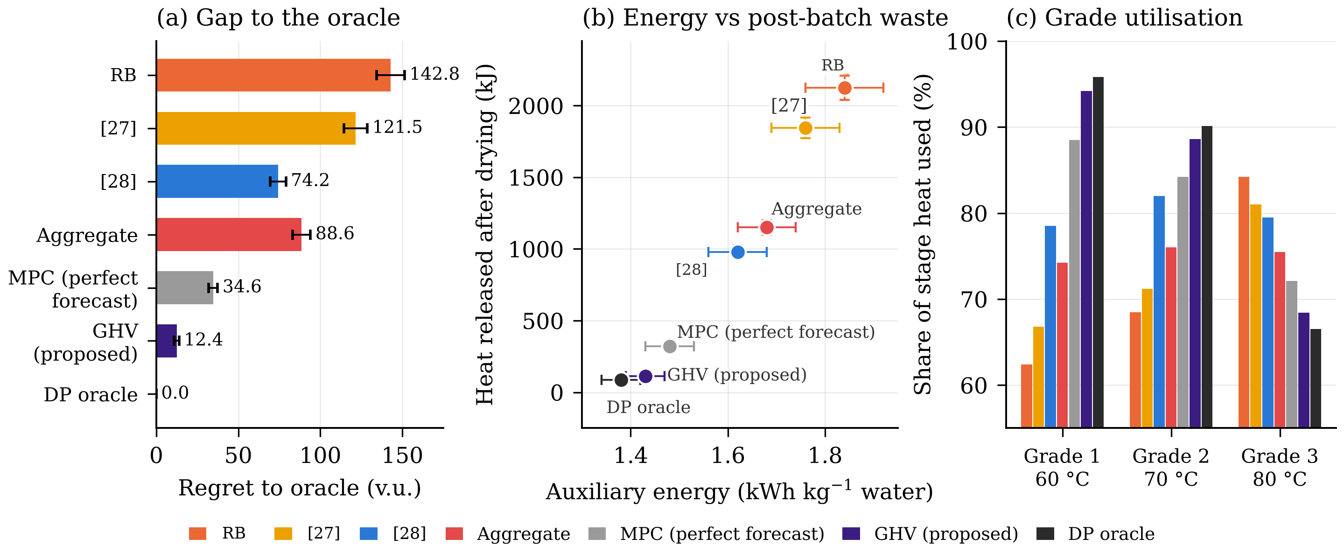
Fig. 5. Graded Heat Value with perfect state and known weather (mean ± SD over test episodes). (a) Regret to the DP oracle. (b) Auxiliary energy against heat released after the product reached its target. (c) Share of each grade’s deliverable heat that was used; GHV and the oracle use low-grade heat first and conserve high-grade heat. The figure supports Propositions 3 and 5: pricing grades lowers regret, conserves high-grade heat and removes most post-batch discharge.

6.4 Decision-Critical Sensing
When the state is unknown, Fig. 6 compares the performance of the state estimation. Rather than dispatching, all estimators use the same price-based dispatch, and so the differences in regret are just a function of the estimation. The PINN [29] also has a lower estimation error as expected, compared to curvature-only DCS (0.048 vs 0.052 v.u.) but suffers from the higher regret value (32.8 vs 21.6 v.u.). The regrets of EKF [28] and unscented Kalman filter (UKF) are 46.2 and 39.5 v.u., respectively. When the price-gap channel is added, the grade-order reversal drops from 8.4% to 1.8%, and regret is decreased to 14.2 ± 1.2 v.u. (Fig. 6b), compared to the 5.2% and 16.0 ± 1.9 v.u. for curvature-only DCS. DCS requires 2.4 probes per batch, which is 71% less than variance-based probing (Fig. 6c). The two best sensor subsets during charging, three during discharging and four during supercooled discharging were the same as the ones used by the model and within 0.4 v.u. of the regret obtained when using all of the sensors, so the placement of sensors can be planned before installation.
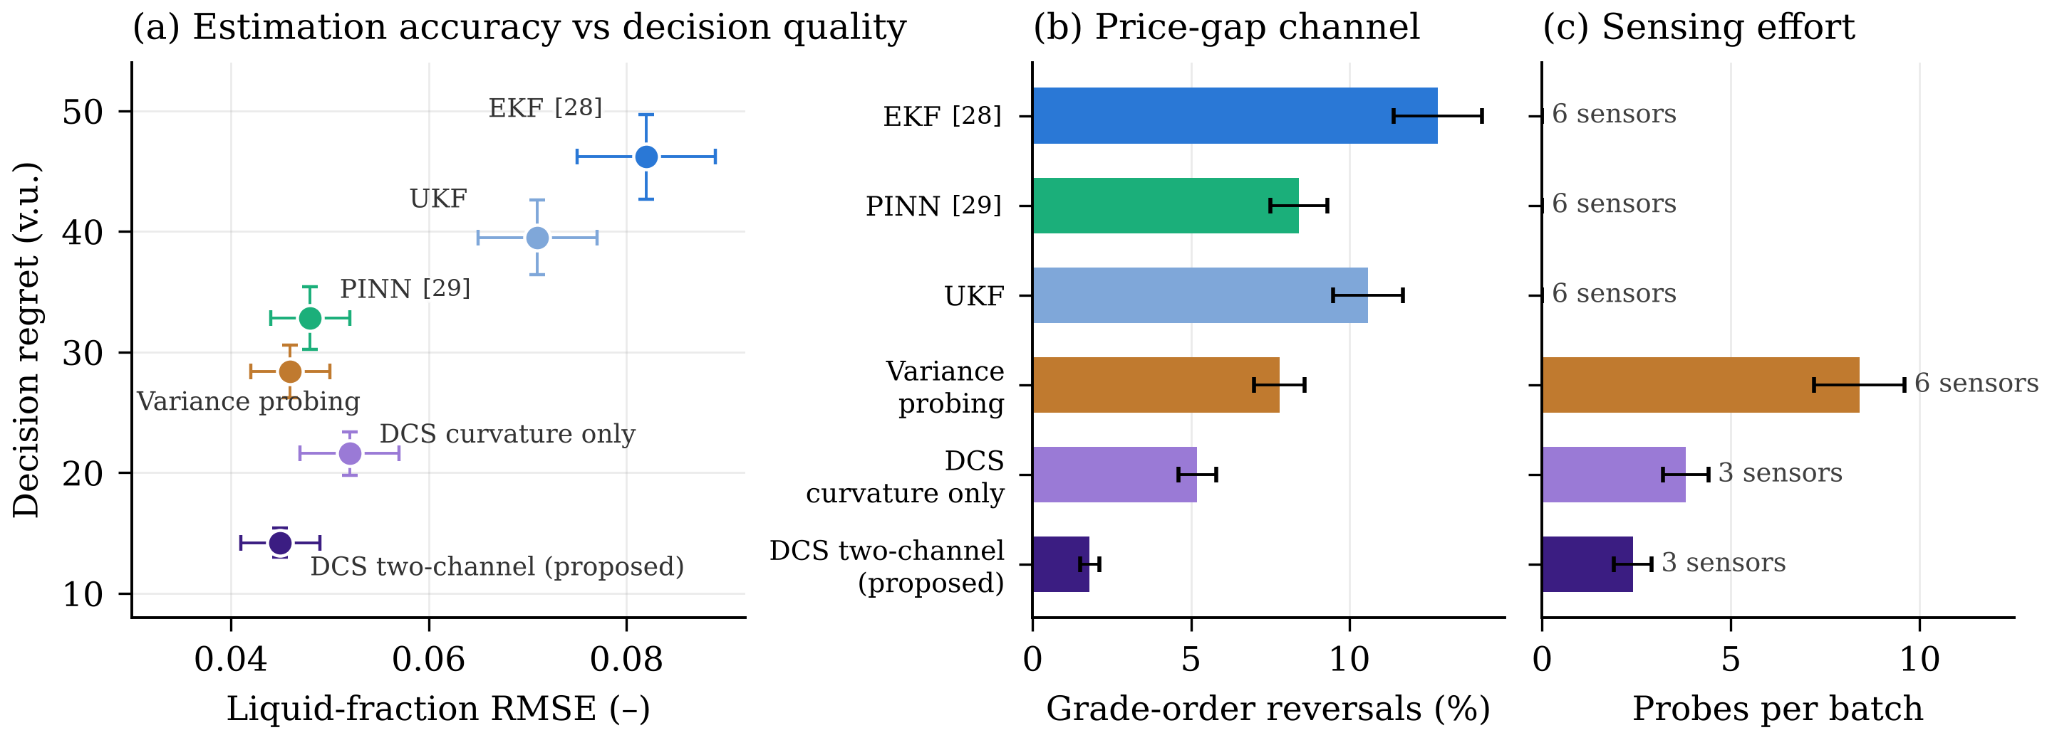
Fig. 6. Under the same dispatch rule, Decision-Critical Sensing. (a) Lower estimation error does not necessarily mean lower decision regret: Liquid-fraction RMSE vs. decision regret. (b) Percentage of decisions where two consecutive grades were used in reverse order (price-gap channel of Eq. 18). (c) Number of probes in a batch and number of sensors used. The figure supports the argument of Section 4.3 that loss of dispatch is related to decision-relevant error, rather than estimation error.

6.5 Mission-Risk Calibration
Learn-then-Test (Fig. 7a) validates a premium only if it records no misses in the 90 calibration episodes (0.95^90 = 0.0099 ≤ δ/|G| = 0.01). Premiums of 0-0.42 had 12-1 misses and were rejected; none of the premiums in the range 0.60-1.75 had misses and the smallest, ρ̂ = 0.60, was deployed as it requires the least energy. In 3 of the 240 test episodes, the fallback controller was activated. The chance-constrained methods [30, 31] missed the target in 11.2%-17.8% of the episodes, while MRC missed in 3.3% (season), 3.3% (product) and 5.0% (degraded PCM) of episodes, with α = 0.05. Robust MPC had the same miss rates as MRC, but required 17.7% more auxiliary energy (Fig. 7c). In other words, MRC does not decrease regret, but rather, it purchases a certified miss rate at a measured energy cost (Section 6.7).
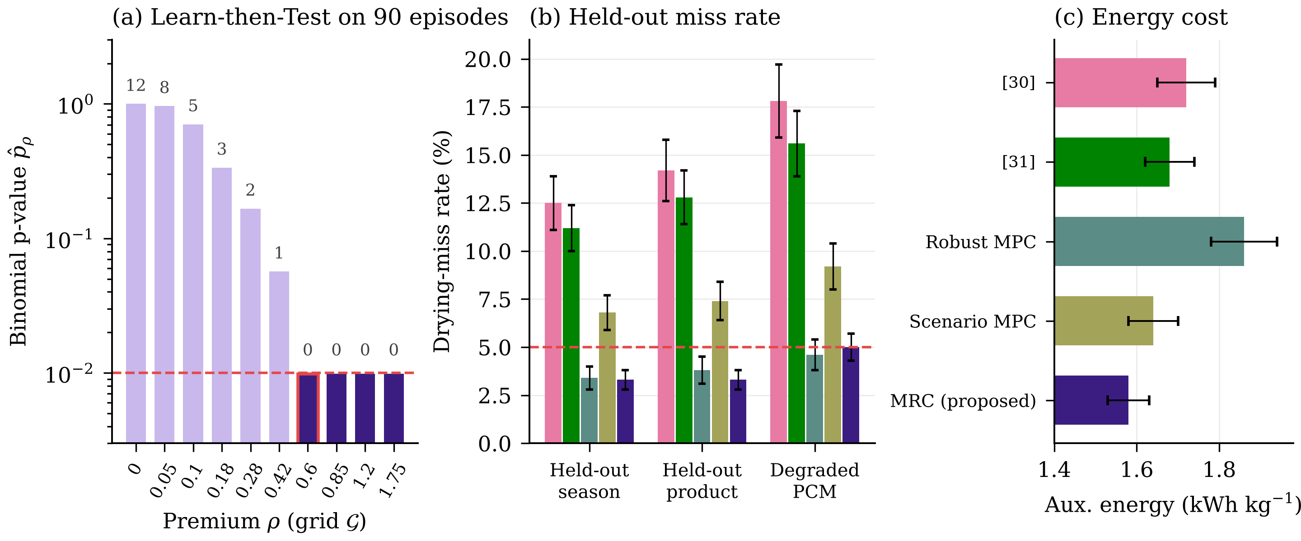
Fig. 7. Mission-Risk Calibration. (a) Learn-then-Test over the premium grid: bar labels provide the number of misses for 90 calibration episodes, dark bars are validated, the red-edged bar is the premium ρ ̂, and the dashed line is the threshold δ/|G| = 0.01. (b) Drying-miss rate on held-out regimes, dashed line is α = 5% and colours are as in panel (c). (c) Auxiliary energy of each method. The figure shows that the miss rate stayed at the nominal level on the held-out regimes tested, at lower auxiliary energy than robust MPC.

6.6 Integrated comparison
CTVD performed well, with 98.3% of target attainment across the 240 paired simulated episodes, an increase of 5.4 percentage points compared to the best re-implemented published baseline [31]. It achieved a 7.1% reduction in drying time, a 13.5% reduction in auxiliary energy, a 85.9% reduction in post-batch heat waste and a 74.1% reduction in oracle regret, and a reduction in temperature violations from 3.1 to 0.4 per episode. Target attainment was 13.7 percentage points higher than in [32] with a corresponding decrease in drying time, energy use, and waste. Using only the realistic forecast, CTVD also outperformed MPC with a perfect forecast, and robust MPC, which matched its miss rate, needed 17.7–25.3% more auxiliary energy (Sections 6.5 and 6.8). Longer planning horizons and learned policies did not eliminate this performance gap. The target attainment rate for full-horizon economic MPC was 94.8%, relative to which CTVD used 8.7% less auxiliary energy, produced 69.7% less post-batch waste and had 57.8% lower regret. The same is true for the SAC controller which reached 94.2% target attainment, while CTVD used 10.4% less auxiliary energy, wasted 74.1% less and regret 61.0% less. These enhancements underscore the benefit of CTVD's focus on the value of stored heat at each decision point, instead of just long-term forecasts.
In practical terms, the auxiliary-energy saving over [31] is 3.5 kWh per batch (22.3 against 25.8 kWh for the potato batch of Table 1, about 15.2 kg of water removed), or 230 kWh per tonne of water; relative to [32] it is 420 kWh per tonne. With the 2022 national average emission factor of the Chinese grid, 0.5366 kg CO₂ kWh⁻¹ [42], which applies to the Lanzhou site, this avoids about 123 kg CO₂ per tonne of water relative to [31] and 225 kg relative to [32], and the savings require no change to the collectors or the store. The framework is also cheap to run: because every online step is a network evaluation or a closed-form rule (Algorithm 1), CTVD needs 18.5 ± 2.2 ms per decision on the workstation of Section 5.1, against 420 ms for tracking MPC [28] and 2.45 s for the chance-constrained dispatch of [31], which is less than 0.01% of the 5 min decision interval. The value and miss-probability networks are trained once offline in 4.8 h; a learned value function is needed for the full plant because one solve of the DP oracle takes 14.2 h and 18.5 GB of memory.
Table 6. Integrated closed-loop comparison under matched conditions (240 paired episodes, mean ± SD).
Method | Target met (%) | Drying time (h) | Aux. energy (kWh kg⁻¹) | Post-batch waste (kJ) | Temp. violations | Regret (v.u.)
[32] | 84.6 ± 2.6 | 11.30 ± 0.11 | 1.89 ± 0.02 | 2121.4 ± 87.4 | 14.0 ± 3.6 | 170.3 ± 8.2
[27] | 89.2 ± 2.2 | 10.88 ± 0.10 | 1.82 ± 0.02 | 1894.2 ± 71.8 | 11.6 ± 3.4 | 143.2 ± 7.9
[28] | 92.1 ± 1.8 | 10.20 ± 0.08 | 1.75 ± 0.02 | 1044.7 ± 48.3 | 6.5 ± 2.6 | 87.3 ± 5.3
[29] | 91.2 ± 1.8 | 9.99 ± 0.07 | 1.72 ± 0.01 | 982.8 ± 43.4 | 5.1 ± 2.3 | 79.2 ± 5.0
[30] | 87.9 ± 2.1 | 10.40 ± 0.09 | 1.77 ± 0.02 | 1114.3 ± 51.9 | 3.7 ± 1.8 | 85.3 ± 5.4
[31] | 92.9 ± 1.7 | 9.92 ± 0.07 | 1.70 ± 0.01 | 889.0 ± 36.0 | 3.1 ± 1.7 | 72.5 ± 4.7
MPC, perfect forecast | 96.7 ± 1.2 | 9.50 ± 0.06 | 1.53 ± 0.01 | 362.1 ± 25.2 | 1.9 ± 1.3 | 38.8 ± 2.9
Economic MPC, 36 h | 94.8 ± 1.4 | 9.68 ± 0.07 | 1.61 ± 0.02 | 415.2 ± 24.5 | 1.8 ± 1.1 | 44.5 ± 3.1
SAC (deep RL) [43] | 94.2 ± 1.5 | 9.75 ± 0.08 | 1.64 ± 0.02 | 485.0 ± 28.2 | 2.1 ± 1.2 | 48.2 ± 3.4
CTVD | 97.3 ± 0.8 | 9.22 ± 0.05 | 1.47 ± 0.01 | 125.7 ± 12.8 | 0.4 ± 0.7 | 18.8 ± 1.4
DP oracle | 100.0 | 8.95 ± 0.05 | 1.47 ± 0.07 | 87.9 ± 7.9 | 0.0 | 0.0

6.7 Ablation and regret decomposition
Table 7 and Fig. 8 remove one component at a time and decompose the regret with Eq. 24. Removing only the merit-order rule lowered target attainment from 98.3% to 92.4%, raised auxiliary energy by 12.9% and more than doubled regret (42.10 against 18.80 v.u.), undoing most of the benefit. Of the explained regret of full CTVD (18.64 v.u.), 45.3% comes from estimation error, 28.8% from risk control and 25.9% from value-function error, with a 0.16 v.u. remainder; estimation is therefore the main target for improvement, and curvature-only DCS raises the estimation term to 12.80 v.u. MRC is a risk–energy trade-off: added to GHV, it raises attainment from 91.2% to 97.2% and provides the certificate of Proposition 8, but it increases regret and auxiliary energy. Its cost is lower with DCS (5.37 against 6.10 v.u.), and a fixed premium in place of the calibrated one nearly triples it (14.93 v.u.) for similar attainment. GHV, DCS and MRC therefore remove different terms of regret, and the higher-order remainder stays below 2.3% of the measured regret.
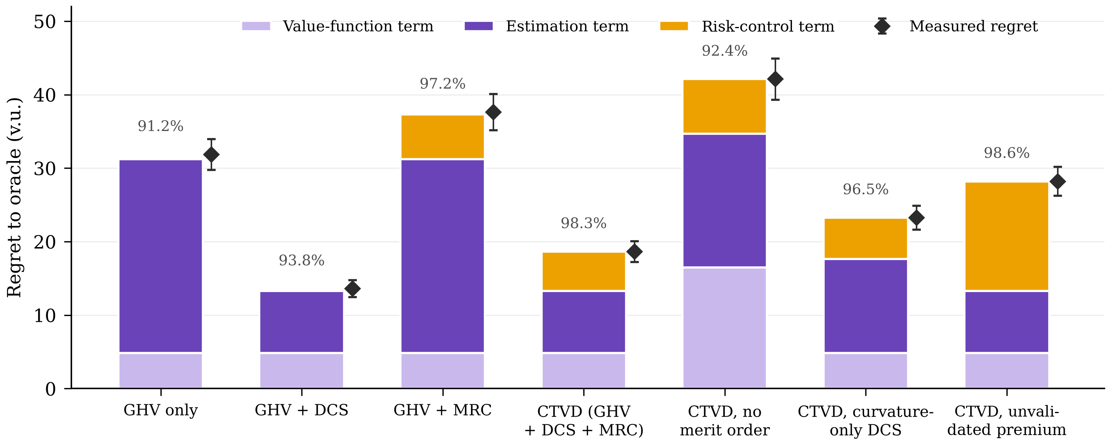
Fig. 8. Ablation and regret decomposition (Eq. 24). The value-function, estimation and risk-control terms are represented by stacked bars; the measured regret (mean ± SD) is represented by diamonds; the numbers above the bars are the percentage of episodes that achieved the target. As depicted in the figure, each component eliminates a different term of regret, which means that the components are complementary and not redundant.
Table 7. Ablation and regret decomposition over 240 matched episodes (mean ± SD; terms of Eq. 24 in v.u.; the last row restricts every valve to on–off operation, Section 6.8).
Configuration | Target met (%) | Aux. energy (kWh kg⁻¹) | Value term | Estimation term | Risk-control term | Remainder | Measured regret
GHV only | 91.2 ± 1.8 | 1.44 ± 0.04 | 4.82 ± 0.35 | 26.40 ± 1.85 | 0.00 | 0.63 | 31.85 ± 2.10
GHV + DCS | 93.8 ± 1.5 | 1.43 ± 0.04 | 4.82 ± 0.35 | 8.45 ± 0.72 | 0.00 | 0.31 | 13.58 ± 1.15
GHV + MRC | 97.2 ± 0.9 | 1.62 ± 0.05 | 4.82 ± 0.35 | 26.40 ± 1.85 | 6.10 ± 0.45 | 0.30 | 37.62 ± 2.45
CTVD (GHV + DCS + MRC) | 98.3 ± 0.8 | 1.47 ± 0.01 | 4.82 ± 0.35 | 8.45 ± 0.72 | 5.37 ± 0.42 | 0.16 | 18.80 ± 1.42
CTVD without merit order | 92.4 ± 1.7 | 1.66 ± 0.06 | 16.50 ± 1.20 | 18.20 ± 1.45 | 7.40 ± 0.55 | 0.00 | 42.10 ± 2.80
CTVD, curvature-only DCS | 96.5 ± 1.1 | 1.51 ± 0.04 | 4.82 ± 0.35 | 12.80 ± 1.05 | 5.63 ± 0.44 | 0.00 | 23.25 ± 1.65
CTVD, unvalidated fixed premium | 98.6 ± 0.7 | 1.74 ± 0.06 | 4.82 ± 0.35 | 8.45 ± 0.72 | 14.93 ± 1.10 | 0.00 | 28.20 ± 1.95
CTVD, on–off valves | 95.8 ± 1.3 | 1.58 ± 0.02 | 23.02 ± 1.45 | 8.45 ± 0.72 | 10.18 ± 0.75 | 0.00 | 41.65 ± 1.80

6.8 Robustness and sensitivity
The CTVD is compared with the best baseline for each perturbation out of the calibration range (Fig. 9). The target was achieved in 96.1–97.8% of episodes with CTVD. Its largest margins were under telemetry dropout (7.6 percentage points over the EKF [28]), severe sensor noise (6.6 points over the PINN [29]), forecast error (5.7 points) and overload (6.0 points over [31]). Robust MPC came within 1.2–1.5 points of CTVD but required 24.4–25.3% more auxiliary energy (1.94 and 1.98 against 1.56 and 1.58 kWh kg⁻¹). The divisibility assumption of GHV was examined individually for all the 240 matched episodes under all of the fully open or fully closed valve cases (Table 7). In 11.6% of jurisdictions price ordering was not executed, target attainment dropped to 95.8% while auxiliary energy increased by 7.5% (1.58 versus 1.47 kWh kg⁻¹). Post batch waste went up from 125.7 to 442.3 kJ, temperature violations from 0.4 to 5.2 per episode, primarily via the value term, which increased from 18.80 to 41.65 v.u. CTVD had better attainment of the targets and lower requirement for auxiliary energy than the best re-implemented published method [31] and higher attainment than [32] (Table 6) despite the presence of on–off valves. Gains over the baselines also exist without proportional valves, so gains due to proportional valves are also a portion of the GHV benefit.
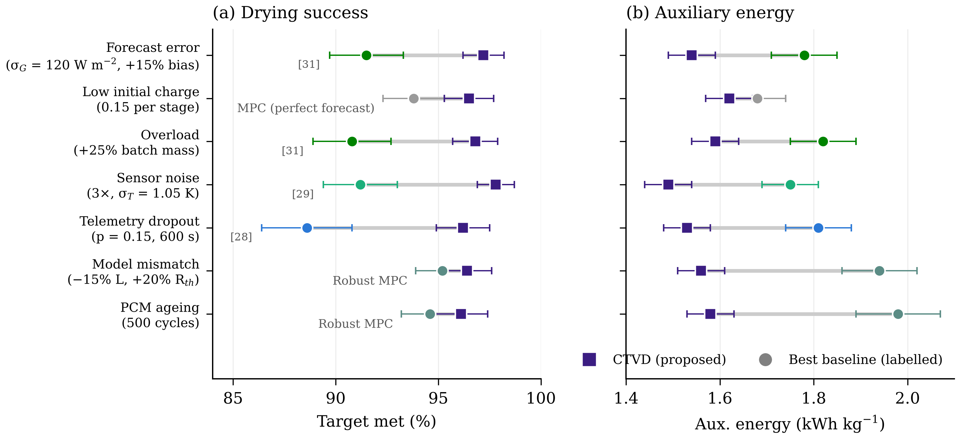
Fig. 9. Robustness of CTVD against the best baseline for each perturbation (labelled). (a) Share of episodes meeting the target. (b) Auxiliary energy. Markers show mean ± SD; grey bars join the two methods. The figure shows that the target-attainment margin of CTVD persists under perturbations beyond the calibration conditions.
Fig. 10 shows the sensitivity to the five user-selected parameters. As the theory predicts, only the risk level α materially moves the operating point: relaxing α from 0.05 to 0.15 lowered attainment from 98.3% to 92.4%, while tightening it from 0.05 to 0.01 raised attainment to 99.4% at the cost of 13% more auxiliary energy. Over the ranges tested, the probe cost, the confidence parameter δ, the size of the premium grid and the retained curvature trace each moved target attainment by at most 1.8 percentage points and auxiliary energy by at most 0.07 kWh kg⁻¹. With 10 or more premiums the attainment was indistinguishable across grid sizes, and retaining only 80% of the curvature trace reduced attainment to 96.8%, which justifies the default of 95%.
Fig. 10. Sensitivity of target attainment (top) and auxiliary energy (bottom) to the probe cost, the risk level $α$, the confidence parameter $δ$, the size of the premium grid and the retained curvature trace. Open red circles mark the setting used in all other experiments. The figure shows that only the risk level materially moves the operating point, so the other settings need no plant-specific tuning over the ranges tested.

6.9 Product-consistency scenarios
Scenarios 1, 2 and 3 of Table 2 were run under the protocol of Table 6 (240 paired episodes, AR(1) forecast error, sensor noise, MR⋆ = 0.05), with only the product changed. Tomato juice was dried as a 2.5 mm foam mat, with Page coefficients fitted to the drying curves of [39] (k = 0.001890 min⁻ⁿ, n = 1.1845 at 60 °C; k = 0.003184 min⁻ⁿ, n = 1.1304 at 70 °C). Tomato pulp was dried as a 2 mm layer without foaming, with coefficients fitted to [40] (k = 0.003119 min⁻ⁿ, n = 1.1562 at 60 °C; k = 0.006168 min⁻ⁿ, n = 1.1679 at 80 °C). For the leaf product of Scenario 3, the Page constants of Moringa oleifera leaves at 1.3 m s⁻¹ were taken from [41] (40–70 °C). The fitted coefficients reproduce the published drying times: they give 8.38 h and 7.12 h to MR = 0.05 for the juice at 60 and 70 °C, against 8.50 h and 7.50 h measured to the powder end-point in [39], and 6.33 h and 3.33 h for the pulp at 60 and 80 °C, ahead of the 9.83 h and 4.00 h measured to moisture equilibrium in [40]. Potato slices (Scenario 3) are the case of Table 6. Each scenario was compared with the reference-dryer control [32], the strongest realistic baseline [31] and MPC with a perfect forecast, with the DP oracle as the reference (Table 8).
Table 8. Closed-loop comparison by product-consistency scenario (240 paired episodes per scenario, mean ± SD). Potato slices (Scenario 3) are reported in Table 6.
Scenario | Method | Target met (%) | Drying time (h) | Aux. energy (kWh kg⁻¹) | Post-batch waste (kJ) | Regret (v.u.)
1: Tomato juice, foam mat 2.5 mm | [32] | 88.3 ± 2.1 | 8.42 ± 0.15 | 1.512 ± 0.025 | 920.0 ± 21.6 | 72.4 ± 2.0
 | [31] | 91.7 ± 1.8 | 8.15 ± 0.13 | 1.441 ± 0.021 | 785.0 ± 17.5 | 64.8 ± 1.7
 | MPC, perfect forecast | 95.8 ± 1.3 | 7.88 ± 0.12 | 1.314 ± 0.019 | 315.0 ± 9.6 | 34.2 ± 1.1
 | CTVD | 98.3 ± 0.8 | 7.65 ± 0.10 | 1.274 ± 0.017 | 138.0 ± 5.8 | 19.5 ± 0.7
 | DP oracle | 100.0 | 7.42 ± 0.10 | 1.228 ± 0.016 | 82.0 ± 3.8 | 0.0
2: Tomato pulp, 2 mm layer | [32] | 89.6 ± 2.0 | 5.35 ± 0.10 | 1.382 ± 0.023 | 790.0 ± 15.0 | 62.5 ± 1.6
 | [31] | 93.3 ± 1.6 | 5.08 ± 0.09 | 1.312 ± 0.019 | 680.0 ± 15.2 | 54.8 ± 1.4
 | MPC, perfect forecast | 96.2 ± 1.2 | 4.82 ± 0.09 | 1.210 ± 0.018 | 265.0 ± 7.9 | 28.6 ± 0.9
 | CTVD | 98.8 ± 0.7 | 4.64 ± 0.08 | 1.160 ± 0.016 | 102.0 ± 4.9 | 15.8 ± 0.6
 | DP oracle | 100.0 | 4.48 ± 0.07 | 1.115 ± 0.015 | 64.0 ± 3.2 | 0.0
3: Moringa leaves, single layer | [32] | 92.5 ± 1.7 | 3.35 ± 0.08 | 1.042 ± 0.019 | 540.0 ± 13.3 | 42.6 ± 1.4
 | [31] | 95.0 ± 1.4 | 3.18 ± 0.07 | 0.982 ± 0.016 | 465.0 ± 11.5 | 36.4 ± 1.1
 | MPC, perfect forecast | 97.5 ± 1.0 | 2.98 ± 0.06 | 0.912 ± 0.016 | 185.0 ± 6.0 | 21.2 ± 0.8
 | CTVD | 99.2 ± 0.6 | 2.89 ± 0.05 | 0.882 ± 0.012 | 78.0 ± 3.6 | 11.5 ± 0.5
 | DP oracle | 100.0 | 2.78 ± 0.05 | 0.845 ± 0.012 | 48.0 ± 2.7 | 0.0
CTVD gave the best value of every metric among the realisable controllers in all three scenarios and came closest to the DP oracle (Table 8). Target attainment was 98.3% for juice, 98.8% for pulp and 99.2% for leaves, 4.2–6.6 percentage points above [31]. Relative to the reference-dryer control [32], CTVD shortened drying by 9.1% (juice), 13.3% (pulp) and 13.7% (leaves), used 15.4–16.1% less auxiliary energy, cut post-batch waste by 85.0–87.1% and lowered regret by 73.0–74.7%. Relative to [31], drying time fell by 6.1–9.1% and auxiliary energy by 10.2–11.6%. Without any forecast, CTVD also dried 2.9–3.7% faster than MPC with a perfect forecast and used 3.0–4.1% less auxiliary energy, the same pattern as for potato slices in Table 6. The largest gains over [32] in drying time are for pulp and leaves, which tolerate the hottest air, and the smallest for the foamed juice, whose air temperature is capped at 70 °C. Drying times differ by product, from 7.65 h for the foamed juice to 2.89 h for the leaves, but the ranking of the methods does not change, because the product enters CTVD only through the Page coefficients of Eq. 2.
Table 9. Share of delivered heat by PCM grade under CTVD and value of grading over grade-blind dispatch (Eq. 15), by product.
Scenario | Product | Grade 1,60°C(%) | Grade 2,70°C(%) | Grade 3,80°C (%) | Δ_{grade}(v.u.)
2 | Tomato pulp, 2 mm | 29.4 | 36.8 | 33.8 | 34.2
3 | Potato slices, 5 mm | 41.2 | 37.4 | 21.4 | 22.8
3 | Moringa leaves | 50.6 | 33.8 | 15.6 | 14.6
1 | Tomato juice, foam mat | 54.2 | 33.5 | 12.3 | 12.4
Table 9 tests the prediction of Eq. 15 that the advantage of grading grows with the use made of the higher grades. The products are ordered by Δ_{grade}: tomato pulp (34.2 v.u.), potato slices (22.8 v.u.), moringa leaves (14.6 v.u.) and tomato juice (12.4 v.u.). The pulp layer tolerates 80 °C air early in the batch, when its moisture flux is high, so CTVD draws on all three grades and Grade 3 supplies 33.8% of the heat. Potato slices use Grade 3 mainly in the late afternoon, when the collector output falls. The short leaf batches (about 2.9 h) finish during midday irradiance and are met largely from Grade 1 (50.6%). For the foamed juice, the air temperature is kept at or below 70 °C to preserve the foam, the upper end of the range measured in [39], so Grade 3 supplies only 12.3% of the heat and the price gaps p₃ − p₁ weigh little in Eq. 15. Graded dispatch therefore gains most for semi-liquid layers and least for heat-sensitive liquids.

6.10 Limitations
There are five major limitations to the research. First, the results from all controllers were simulated, and only the results from the cabinet-temperature and drying responses of the reference dryer were validated with measured data. Slice shrinkage, and non-uniform airflow, are unmodelled effects which must be determined by physical or pilot-scale testing. Second, risk guarantees are only valid for shifts represented by the calibration data, and the dependency between consecutive days and larger shifts needs to be validated. Third, proportional valves are needed to achieve price ordering; with on–off valves, target attainment dropped from 98.3% to 95.8%, and post-batch waste rose from 125.7 to 442.3 kJ. Fourth, the baselines were re-implemented on the simulator, and their performance is likely to vary with the same tuning budgets on the original plants. Fifth, the evaluation was conducted for one plant configuration and Lanzhou climate. Other plants need to be validated for grade-price spreads and expected benefits prior to deployment.
7. Conclusion
The value of the stored heat is determined by the temperature grade, drying demand and future use of the heat in the CTVD framework. Graded Heat Value is used for dispatch priority, Decision-Critical Sensing is used for measurements that are relevant to decisions, and Mission-Risk Calibration is used to manage uncertainty under calibrated conditions. CTVD was verified numerically against a dynamic-programming oracle, and achieved 98.3% target attainment, 13.5% reduction in auxiliary energy, and 85.9% reduction in post-batch waste, compared with the best re-implemented baseline. For the simulated tomato juice and tomato pulp drying, and moringa-leaf drying, the target was attained at 98.3–99.2%, with the auxiliary energy being 15.4–16.1% less than that of the reference-dryer controller. Future work will be on physical-dryer validation, proportional valves, better risk guarantees, and better sensing.
Data availability
The validation datasets are those of Rulazi et al. (2023) [36], Alimi et al. (2025) [37] and Zemanek et al. (2026) [38]. The simulator source code, the trained value and miss-probability networks, the list of random seeds, the day-level data splits and the implementation notes for each re-implemented baseline are available from the corresponding author upon reasonable request.
Appendix A. Proofs
Proof of Proposition 1. From Eq. 3, $ln β = const - u + ζ ln u + ln(ξ + ln u)$ on $u > e^{-ξ}$, so $∂_{u} ln β = -g(u)/u$ with $g(u) = u - ζ - 1/(ξ + ln u)$. Since $g'(u) = 1 + 1/[u(ξ + ln u)^{2}] > 0$, $g$ is strictly increasing; it tends to $-∞$ as $u ↓ e^{-ξ}$ and to $+∞$ as $u → ∞$. Hence $g$ has a unique root $u^{†}$, $β$ increases before it and decreases after it, and $u^{†}$ is the unique maximum. Substituting $u^{†}$ and $u_{f}$ in Eq. 3 gives $Λ$ in Eq. 4. With the reference-dryer coefficients, $ζ' = n'/n^{2} > 0$ because $n'(T) = 0.018 - 0.0002T > 0$ for $T < 90$ °C, and $b' > 0$ was confirmed numerically over 40–80 °C, so the conditions of the proposition hold. ▫
Proof of Proposition 2. Compare two states that differ only in where one extra unit of deliverable heat is stored: at grade $j - 1$ (state A) or at grade $j$ (state B). By Eq. 5, moving the unit from grade $j - 1$ to grade $j$ raises $q_{j}$ by one unit and leaves every other cone coordinate unchanged. Let $π$ be optimal from A. Under divisible dispatch, Eq. 6 lets a policy started from B deliver, at every instant, the same air-temperature and power profile as $π$, drawing from stage $j$ whatever $π$ draws from stage $j - 1$ out of the extra unit. Because the marginal standing loss of deliverable heat does not increase with grade, the unit held at grade $j$ is depleted no faster than at grade $j - 1$, so the replicated profile stays feasible until $π$ spends the unit. Hence $V(B) ≥ V(A)$, that is $∂V/∂q_{j} = p_{j} - p_{j-1} ≥ 0$ for $j = 2, 3$. Adding heat never removes a feasible plan, because unused heat can be left in the store, so $p_{1} = ∂V/∂q_{1} ≥ 0$, and Eq. 10 follows. With on–off valves a higher stage cannot be throttled to the outlet temperature of a lower stage, Eq. 6 fails and the replication step is no longer available. ▫
Proof of Proposition 4. Along the optimal path $p_{k}$ is the costate of $h_{k}$. With $Q_{k}^{c}$ independent of $h_{k}$, $h_{k}$ enters the augmented Hamiltonian only through $-p_{k} l_{k}(h_{k})$ and $μ_{k} {P̄}_{k}(h_{k})$, so the costate equation $ṗ_{k} = -∂H/∂h_{k}$ gives Eq. 12. Because $MV$ depends on $q$ only through $V(q,0,t)$, $∇_{q} V$ is the same immediately before and after a reload, so prices are continuous across a reload. ▫
Proof of Proposition 5. In $W$, $u ≥ u^{†}$ and $u$ increases, so $β(u(t),T̄)$ strictly decreases in $t$ (Proposition 1). Since $ψ$ is non-increasing and $T̄$ and $ṁ$ are constant, $g(t) = ψ(t) β(u(t),T̄)/(ṁ c_{p})$ strictly decreases. With slack bounds $μ_{k} = 0$, so Eq. 12 with $∂l_{k}/∂h_{k} ≥ 0$ gives $ṗ_{k} ≥ 0$. Hence $η_{k} g(t) - p_{k}(t)$ is strictly decreasing, crosses zero at most once, at $t_{k}^{off}$, and grade $k$ stays off afterwards. Grade $k$ is off when $g(t) < p_{k}(t)/η_{k}$. If $η_{3}/p_{3}(t) ≤ η_{2}/p_{2}(t) ≤ η_{1}/p_{1}(t)$ on $W$, the thresholds satisfy $p_{3}/η_{3} ≥ p_{2}/η_{2} ≥ p_{1}/η_{1}$ at every instant, so the decreasing $g(t)$ falls below the grade-3 threshold first and $t_{3}^{off} ≤ t_{2}^{off} ≤ t_{1}^{off}$. ▫
Appendix B. Conditions for the regret identity (Proposition 9)
Proposition 9 uses Lipschitz dynamics on a bounded set $X$ and a comparison principle for the quasi-variational inequality of Eq. 8. For impulse-control problems of this type, existence and uniqueness of viscosity solutions to the quasi-variational inequality are established in [34] under conditions of the following kind, each checked here against the plant of Section 3.
C1 (Lipschitz dynamics). The right-hand sides of Eqs. 1–2 must be Lipschitz in $x$, uniformly in $a$. Eq. 1 is affine in $P_{k}$ and $P_{aux}$, the enthalpy–temperature map of each stage is continuous and piecewise linear, and softplus is 1-Lipschitz, so the heat balances satisfy C1. Eq. 2 is Lipschitz except at $u = 0$, where $u^{ζ}$ with $0 < ζ < 1$ has unbounded slope. The analysis therefore takes $X$ with $u ≥ u_{0} > 0$, where $u_{0}$ is the dryness reached in the first plant step (10 s) after a reload.
C2 (compact actions, bounded rewards). The action set is compact: $0 ≤ P_{k} ≤ {P̄}_{k}$, $0 ≤ P_{aux} ≤ 3.5$ kW and $ṁ ∈ [0.035, 0.120]$ kg s⁻¹ (Table 1). On $X$ the running reward $ρ_{w} e^{-u} u̇ - c_{a} P_{aux}$ is bounded and Lipschitz.
C3 (continuous data). The comparison principle is stated for continuous rewards, whereas $r(u)$ contains the indicator $1\{u ≥ u^{⋆}\}$. Proposition 9 is therefore applied to the regularised reward in which the indicator is replaced by a linear ramp of width $ε_{r}$ below $u^{⋆}$. Because $1\{u ≥ u^{⋆}\}$ is upper semicontinuous and is the decreasing limit of these ramps, the regularised values converge to $V$ as $ε_{r} → 0$.
C4 (positive impulse cost). Each reload costs $c_{r} = 15$ v.u. > 0 (Table 1), so only finitely many reloads occur on $[0, T_{h}]$ and the reload operator $M$ satisfies the conditions of [34].
Under C1–C4, Eq. 8 has a unique viscosity solution [34], which provides the comparison property used here. A function whose residual $ϵ_{θ}$ (Eq. 16) is small is then within a constant multiple of $ϵ_{θ}$ of $V$ on $X$, with the constant depending on $T_{h}$ and $c_{r}$, and its greedy policy loses at most $L_{V} ϵ_{θ}$; this is the bound on the first term of Eq. 24. The second term is a second-order expansion of the dispatch loss in the estimation error (Eqs. 17–18), with remainder $o(Σ)$, and the third term is evaluated exactly. The three terms sum to the left side of Eq. 24 by telescoping, whatever the accuracy of the individual approximations.
References
- A. Kumar, S. Biswas, R. Kumar, A. Mandal, Experimental appraisal & dual efficiency optimization of a modified indirect solar dryer: Heat & mass transfer analysis with a hybrid ANN approach, Renew. Energy 249 (2025) 123098. https://doi.org/10.1016/j.renene.2025.123098
- /A.D. Dhass, N. Beemkumar, M. Sunil Kumar, G. Subbiah, R.P. Singh, K. Kamakshi Priya, Enhancing solar drying systems through integrated thermal energy storage and solar-assisted heat pump technologies: A pathway to sustainable food processing, Results Eng. 28 (2025) 107125. https://doi.org/10.1016/j.rineng.2025.107125
- V.S. Krishna, S.K. Jain, N.L. Panwar, R. Sree, An overview on phase change material incorporated in convective solar dryers, J. Energy Storage 131 (2025) 117486. https://doi.org/10.1016/j.est.2025.117486
- /J. Wu, J. Fan, T. Ma, W. Kong, Z. Chang, X. Li, Identifying driving factors in cascaded packed bed latent thermal energy storage: An experimental validation, Renew. Energy 224 (2024) 120191. https://doi.org/10.1016/j.renene.2024.120191
- /X. He, W. Wang, Y. Shuai, Y. Hou, J. Qiu, Dynamic thermal performance analysis and experimental study of cascaded packed-bed latent thermal energy storage integrated solar trough collectors, Renew. Energy 232 (2024) 121043. https://doi.org/10.1016/j.renene.2024.121043
- /M.S. Kabasa, S. Biira, P. Tumutegyereize, Numerical investigation of cascaded phase-change material mass ratios for latent heat thermal energy storage in solar crop drying, Discov. Energy 6 (2026) 66. https://doi.org/10.1007/s43937-026-00167-y
- E.S. ELSihy, C. Cai, Z. Li, X. Du, Z. Wang, Performance investigation on the cascaded packed bed thermal energy storage system with encapsulated nano-enhanced phase change materials for high-temperature applications, Energy 293 (2024) 130554. https://doi.org/10.1016/j.energy.2024.130554
- Y. Gao, X. Sun, Z. Zhang, T. He, Z. Dai, X. Dong, C. Wang, X. She, G. Yin, Thermal grade regulation of cascaded packed-bed thermal storage for liquid air energy storage coupled with coal-fired power plants, Appl. Therm. Eng. 306 (2026) 133239. https://doi.org/10.1016/j.applthermaleng.2026.133239
- M. Efendi, Influence of glazing type on the drying kinetics and thermal performance of indirect solar dryer for jelly candy, Renew. Energy 231 (2024) 120950. https://doi.org/10.1016/j.renene.2024.120950
- /D. Rodríguez-Ortiz, A.Y. Alanis, Á. Tlatelpa Becerro, J. Escobedo Bretado, J.D. Rios, E.C. López-Vidaña, Prediction of drying kinetics and microclimate conditions in a tunnel-type solar dryer using multilayer perceptron neural networks, Processes 14 (2026) 675. https://doi.org/10.3390/pr14040675
- A.A. Alhashmi, C. Sureshkumar, G. Aldehim, M.H. Alghamdi, R. Alabdan, M.M. Alnfia, A. Munimathan, S. Vivek, Thermodynamic optimization of active and passive indirect solar dryers through hybrid ANN–RSM energy modeling, J. Therm. Anal. Calorim. 151 (2026) 11091–11114. https://doi.org/10.1007/s10973-026-15672-4
- /S. Rejabov, B.S. Usmonov, K. Usmanov, J. Eshbobaev, M. Yusupov, Development of a temperature regulation system for solar dryers based on artificial neural network-driven intelligent control, Eng. Proc. 117 (2025) 53, published online 14 February 2026. https://doi.org/10.3390/engproc2025117053
- S. Tarvainen, E. Hirvijoki, T. Laukkanen, Evaluation of reinforcement learning and model predictive control for apartment heating with heat pump and water storage tank, J. Energy Storage 152 (2026) 120509. https://doi.org/10.1016/j.est.2026.120509
- /A.C. Nunna, O. Galteland, L. Georges, Y. Zong, Optimal control of a bio-based phase change material thermal energy storage for demand response, Energy Convers. Manag. 326 (2025) 119476. https://doi.org/10.1016/j.enconman.2024.119476
- /Y. Chen, I. Marotta, V. Palomba, T. Ohlson Timoudas, Q. Wang, Model predictive control guided imitation learning for optimal control of PCM thermal energy storage, Appl. Therm. Eng. 295 (2026) 130741. https://doi.org/10.1016/j.applthermaleng.2026.130741
- /H. Bastida, I. De la Cruz-Loredo, P. Saikia, C.E. Ugalde-Loo, Discrete-time state-of-charge estimator for latent heat thermal energy storage units based on a recurrent neural network, Appl. Energy 371 (2024) 123526. https://doi.org/10.1016/j.apenergy.2024.123526
- /J. Wilson, R.J. Barthorpe, F. Terzioglu, Alternative sensing for state-of-charge estimation of latent heat thermal energy storage, Energies 18 (2025) 2853. https://doi.org/10.3390/en18112853
- /M. Habib, Y. Elomari, F. Hochwallner, A. Buruzs, T. Barz, Q. Wang, Extended Kalman filter on sparse identification of nonlinear systems: application to the SoC estimation of a phase change material-based energy storage, Energy Convers. Manag. X 27 (2025) 101199. https://doi.org/10.1016/j.ecmx.2025.101199
- C. Pan, Y. Li, State of charge estimation for latent-heat thermal energy storage using data-driven hysteresis modeling and Koopman state observer, J. Energy Storage 153 (2026) 120954. https://doi.org/10.1016/j.est.2026.120954
- /B.Y. Ekren, D. Huo, N. Balta-Ozkan, Comfort-aware distributionally robust chance-constrained scheduling of PV-assisted heat pumps under dynamic tariffs: A DOE–ANOVA interaction analysis, Appl. Therm. Eng. 298 (2026) 130832. https://doi.org/10.1016/j.applthermaleng.2026.130832
- N. Vigneshkumar, M. Venkatasudhahar, P. Manoj Kumar, A. Ramesh, R. Subbiah, P. Michael Joseph Stalin, V. Suresh, M. Naresh Kumar, S. Monith, R. Manoj Kumar, M. Kriuthikeswaran, Investigation on indirect solar dryer for drying sliced potatoes using phase change materials (PCM), Mater. Today Proc. 47 (2021) 5233–5238. https://doi.org/10.1016/j.matpr.2021.05.562
- B. Das, P. Singh, P. Kalita, Sustainable drying of Baccaurea ramiflora using a mixed-mode solar dryer with thermal energy storage: A comprehensive 4E analysis, Renew. Energy 252 (2025) 123517. https://doi.org/10.1016/j.renene.2025.123517
- A.A.A. Abuelnuor, M.T. Amin, M.A. Abuelnour, O. Younis, A comprehensive review of solar dryers incorporated with phase change materials for enhanced drying efficiency, J. Energy Storage 72 (2023) 108425. https://doi.org/10.1016/j.est.2023.108425
- /A.K. Atsbeha, T.A. Berhe, M.T. Gebru, Modelling and analysis of flat plate solar air collector with phase change materials for extended surface, drying application, Discov. Energy 6 (2025) 4. https://doi.org/10.1007/s43937-025-00113-4
- P. Choubey, H. Sinhmar, S. Tiwari, A review on machine learning assisted solar drying system with phase change material, J. Energy Storage 119 (2025) 116403. https://doi.org/10.1016/j.est.2025.116403
- S. Chen, X. Cai, Y. Xiao, Improving the performance of solar drying systems through phase change energy storage and AI-based optimization techniques: trends and applications, Appl. Energy 427 (2027) 128805, available online 2026. https://doi.org/10.1016/j.apenergy.2026.128805
- N. Rajamurugu, B. Srimanickam, K. Elangovan, P. Sarasu, Performance evaluation and machine learning-based prediction of PCM-integrated solar chimney drying for black dates, Results Eng. 28 (2025) 108218. https://doi.org/10.1016/j.rineng.2025.108218
- H. Wan, Y. Gong, C. Dang, S. Wang, G. Huang, Power control of latent heat thermal energy storage units using a model-based predictive strategy, Appl. Energy 382 (2025) 125220. https://doi.org/10.1016/j.apenergy.2024.125220
- T. Zhao, J. Wei, S. Du, H. Shan, R. Wang, A physics-informed neural network framework for state estimation of latent heat thermal energy storage: temperature reconstruction and state-of-charge prediction, Energy Convers. Manag. 351 (2026) 121051. https://doi.org/10.1016/j.enconman.2026.121051
- /J.A. Dominguez, N. Henao, A. Parrado, K. Agbossou, J. Campillo, L. Rueda, Risk-aware distributed chance constrained energy coordination in energy communities, Energy 318 (2025) 134778. https://doi.org/10.1016/j.energy.2025.134778
- /W. Zhang, Y. Chen, R. Xie, Y. Xu, A multi-timescale and chance-constrained energy dispatching strategy of integrated heat-power community with shared hybrid energy storage, J. Energy Storage 97 (2024) 112505. https://doi.org/10.1016/j.est.2024.112505
- /X. Li, Y. Gao, G. Yuan, X. Guo, J. Li, Performance optimization of a solar drying system with cascaded phase change thermal storage based on dynamic drying model, Renew. Energy 263 (2026) 125444. https://doi.org/10.1016/j.renene.2026.125444
- /A.N. Angelopoulos, S. Bates, E.J. Candès, M.I. Jordan, L. Lei, Learn then test: Calibrating predictive algorithms to achieve risk control, Ann. Appl. Stat. 19 (2025) 1641–1662. https://doi.org/10.1214/24-AOAS1998
- /M. Perninge, Probabilistic representation of viscosity solutions to quasi-variational inequalities with non-local drivers, ESAIM Control Optim. Calc. Var. 29 (2023) 25. https://doi.org/10.1051/cocv/2023015
- X. Fang, L.-W. Fan, Q. Ding, X. Wang, X.-L. Yao, J.-F. Hou, Z.-T. Yu, G.-H. Cheng, Y.-C. Hu, K.-F. Cen, Increased thermal conductivity of eicosane-based composite phase change materials in the presence of graphene nanoplatelets, Energy Fuels 27 (2013) 4041–4047. https://doi.org/10.1021/ef400702a
- E.L. Rulazi, J. Marwa, B. Kichonge, T. Kivevele, Development and performance evaluation of a novel solar dryer integrated with thermal energy storage system for drying of agricultural products [dataset], Mendeley Data, V1, 2023. https://doi.org/10.17632/cgjpm86mwg.1
- /F. Alimi, N.H. Alrasheedi, M. Edalatifar, J. Shafi, K. Hajlaoui, S. Chebaane, M. Bouzidi, M. Ghalambaz, Dataset: Artificial intelligence – computational fluid dynamics study close contact melting of phase change materials in a finned shell-tube energy storage [dataset], Mendeley Data, V1, 2025. https://doi.org/10.17632/7ht7jcpnjj.1
- /J. Zemánek, A. Václavík, R. Hercík, R. Byrtus, Z. Machacek, F. Schwär, M. Walter, R. Martinek, J. Koziorek, I.A. Abdelhameed, Data for study: Experimental evaluation of a modular phase-change material-based thermal energy storage system [dataset], Zenodo, 2026. https://doi.org/10.5281/zenodo.18595890
- D.M. Kadam, S. Balasubramanian, Foam mat drying of tomato juice, J. Food Process. Preserv. 35 (2011) 488–495.
- /R.V.B. Fernandes, F. Queiroz, D.A. Botrel, V.V. Rocha, C.F. Lima, V.R. Souza, Foam mat drying of tomato pulp, Biosci. J. 29 (2013) 816–825.
- /K.D.R. Ramarao, Z. Razali, C. Somasundram, Mathematical models to describe the drying process of Moringa oleifera leaves in a convective-air dryer, Czech J. Food Sci. 39 (2021) 444–451. https://doi.org/10.17221/257/2020-CJFS.
- Ministry of Ecology and Environment of the People’s Republic of China, National Bureau of Statistics of China, Announcement on the release of the 2022 electricity carbon dioxide emission factors, Beijing, December 2024
- T. Haarnoja, A. Zhou, P. Abbeel, S. Levine, Soft actor-critic: Off-policy maximum entropy deep reinforcement learning with a stochastic actor, in: Proc. 35th Int. Conf. Mach. Learn. (ICML), PMLR 80 (2018) 1861–1870.

